CHANTIERS SOCIAUX MAROCAINS – ICYE MOROCCOCSM 2020-2021PROGRAMSCHANTIERS SOCIAUX MAROCAINS GENERAL INFORMATION 1- CSM what is it ?CHANTIERS SOCIAUX MAROCAINS - CSM is a non-profit NGO. It was created in 10 October 1963 CSM is a network of 45 local groups in Morocco.OUR VISION: Towards an inclusive society rich of volunteering culture and citizenship spiritOUR MISSIONS: CHANTIERS SOCIAUX MAROCAINS – CSM works for : Awareness of the importance of volunteering and the need to its recognize and reinforce the values of citizenship and strengthen the capacity of the population to contribute to sustainable development2-What is CSM workcamp conception?A workcamp is a sort voluntary service. The participants in this activity try to work together for a common aim.This means that all the participants must be actively involved in this service and be well motivated to do it.A workcamp is also an opportunity for young people to exchange experiences and to achieve an intercultural learning process so as to build a word of peace and mutual understanding.The work greatly varies from one project to the other. It normally involves Construction work in remote educative, social and cultural establishments, nature conservation work, and restoration of historical monuments, bricks molding, health and Aids awareness campaigns, sanitation projects such as digging water wells and erecting Blair toilets. The communities may ask us to perform other specific tasks outside the scope of our agreement. This is seen as a way of promoting intercultural understanding.CSM organize sometime some special projects such: •Cultural program •Language Teaching •Easter Camp •Summer camps •Teenager Camps •Medium/Long term Program CSM’s camps don’t require manual skills, but they need strong motivation and well understanding of the local culture and difficulties. The people you are going to meet are open-minded and tolerant; they are ready to achieve with you a constructive dialogue about all the subjects you want to discuss with them.

3-Who can participate?All the people between 18 to 60 years old can participate; some exception could be done for older motivated people.4-InsuranceCSM provides all the participants with an insurance which covers only the work accidents. For other illness, the participants should have their own insurance.5-The Lodging and BoardThe participants in a workcamp live mostly in simple accommodation, school residences, youth or childrencentres, sometime in tents and also host families in cultural projects. Those places have in general basic equipments. In the beginning and in the end of the workcamps the participants are invited to clean the accommodation place and make some arrangements to make it more comfortable. We recommend to all the volunteers to take their sleeping bag.6-Leisure timeEvery locality has its characteristics, in the beginning of the workcamp the animator introduce the region to thevolunteers and try to make a programme together. The participants are invited to contribute actively toelaborate and achieve this programme; they are also invited to bring with them musical materials, games andsome information material about your home country.In free time, the participants are free to organize their own activities, but they should inform the animators before.7-General informationOrganisation : CHANTIERS SOCIAUX MAROCAINSAdresse : BP 456 Rabat, Morocco Tél : +212537262398, Fax : +212537262398, Email Contact :csm_morocco@yahoo.fr Contact personsGeneral issues: Raziq Abderrazzak, Tél:+212661439533, csm_morocco@yahoo.fr Short term Medium/Long term: Hamid Gharbal, Tél:+212655832272, csmmorocco@gmail.com csm_morocco@yahoo.fr

Hamid.gharbal@gmail.com

Tél/Fax : +212537732266Emergency phone number . + 00212617332316

**Website**

**https://www.icye-csmmorocco.org/**

**Facebook page**

[**https://m.facebook.com/icyecsm/?tsid=0.6642716737654883&source=result**](https://m.facebook.com/icyecsm/?tsid=0.6642716737654883&source=result)

**youtube channel**

[**https://m.youtube.com/channel/UCdb7D7IF8DdamZEg2GPqxeA**](https://m.youtube.com/channel/UCdb7D7IF8DdamZEg2GPqxeA)

**instagram**

[**https://www.instagram.com/csmicyemorocco/**](https://www.instagram.com/csmicyemorocco/)

National public Holidays 2019/2020

<https://www.timeanddate.com/holidays/morocco/2020>



**Chantiers Sociaux Marocains**

RP. : 456 Rabat RP. Maroc Tél./Fax : (212) 537 26 23 98 E-mail : csm_morocco@yahoo.fr

|  |
| --- |
| *VOLUNTARY WORK PLACEMENT* |

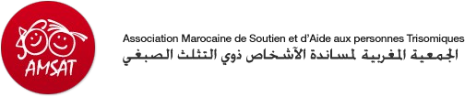

|  |  |
| --- | --- |
| **NAME OF THE PROJECT AND CODE** | **AMSAT Association Marocaine de Soutien et d'aide aux personnes trisomiques (Moroccan Association of Support for Down Syndrome People)**  [www.amsat.ma](http://www.amsat.ma/)  **CODE, CSM77.1** |
| **ADDRESS**  **COUNTRY**  **PHONE/FAX**  **EMAIL**  **CONTACT PERSON** | Centre Son Altesse Royale le Prince Moulay Rachid  Rabat - Morocco  Contact person central office: + 212 655832272 HAMID  **Emergency contact :** + 212 617332316 |
| **PROJECT’S TOPIC** | Children with trisomy |
| **AIMS OF THE PROJECT** | The values affirmed by AMSAT express a set of principles and convictions.  The association works: • For the dignity of persons with Down syndrome • To ensure inclusion and decent living conditions to people with Down syndrome  • For the respect of the uniqueness of each individual • To cultivate the spirit of tolerance, open-mindness and solidarity • To participate in the general progress of our society through the assistance of everyone, regardless of differences. |
| **PROJECT’S ACTIVITIES** | To achieve their goals, thei developped social inclusion strategies. Their center offers a number of multidisciplinary services to stimulate, develop or rehabilitate physical, psychological, relational, language and cognitive Down syndrome.  AMSAT provides: • Orientation • Coeducation • Parental support and early intervention • Specific rehabilitations • Psychological counseling • External outreach and integration  The association carries out its activity through: • Welcoming, listening, informing and guiding the children with Down syndrome and their families. • Promoting co-education approaches and orienting towards self-determination. • Helping families and young people to build an individual life plan. • Offering individual projects. • Working for social integration at all levels: family, school, work, sports and culture. • Implementing all that may be necessary to the physical, intellectual and moral development of the persons with Down syndrome, in accordance with their aspirations. • Defending and promoting the social integration of people with Down syndrome. |
| **COMMUNITY CONTEXT** | The center hosts several disabled children and the volunteers will participate in their everyday life habits and culture through practical and social involvement. They will get in touch with national volunteers and social workers in the center so that they can get involved in the community, not only inside the center but also outside of work.  **Rabat** is the capital and fourth largest city of Morocco with an average population of 580,000 people. It combines both Mediterranean and Oceanic influences on many aspects. Rabat’s climate is mild and temperate, with cool winters and warm summer days. The city is quite dynamic as far as cultural activity is concerned thanks to many structures (Theatre Mohammed V right in the city centre, Cinema Renaissance, official galleries and the archaeological museum) and active associative work.  Further information about the country will be attached in the National Profile form. |
| **VOLUNTEER’S REQUIREMENTS** | • No previous working experience required although pedagogical skills would give extra quality to the project.  • Enthusiastic, positive, patient and respectful people needed.  • People psychologically prepared to work with children suffering various disabilities.  • Willingness to develop ties with other nationalities and learn new things, of course we encourage everyone to follow the pace they feel comfortable with. |
| **VOLUNTEER’S TASKS** | • Organize educational workshops: dance and corporal expression, fine arts, origami, paper recycling, gardening, etc.  • Organize sports activities: physical condition, golf, horse riding, judo, football, etc.  • Assist the teachers in the realization of school related activities.  • Assist the professionals in the realization of stimulation activities: speech therapy, physiotherapy, etc. |
| **ACCOMMODATION**  **DETAILS** | Volunteers will be placed in host families. Further information will be given in due time. |
| **ARRIVAL OPTIONS AND MEETING POINT** | • If you choose to arrive directly in Rabat Airport, we can arrange someone to pick you up for 150 dirhams, otherwise the meeting point will be Rabat Ville Train Station.  • To get to the Rabat Ville Train Station from the airport you can take the bus right outside the gate for 20 dirhams and it will leave you in front of the train station. With a taxi, it should cost you about 100 dirhams (price negotiable).  • If you arrive in any other airport of the country, you will be able to reach Rabat by train, check the timetable and connections on [www.oncf.ma](http://www.oncf.ma/)  Once you have your flights details please pass them by e-mail to your interlocutor so you can arrange with him/her the meeting point.  The info sheet will be send to you by e-mail 3 weeks prior departure. |

----------------------------

**Chantiers Sociaux Marocains**

RP. : 456 Rabat RP. Maroc Tél./Fax : (212) 537 26 23 98 E-mail : csm_morocco@yahoo.fr

|  |
| --- |
| *VOLUNTARY WORK PLACEMENT* |

|  |  |
| --- | --- |
| **NAME OF THE PROJECT AND CODE** | **Disability and Solidarity Centre Annour**  **CODE CSM78.2** |
| **LOCATION**  **ADDRESS**  **COUNTRY**  **PHONE/FAX**  **EMAIL**  **CONTACT PERSON** | 1-Rabat/Sale ANNOUR centre, bab Chaafa Sale    Contact person central office: + 212 655832272 HAMID  **Emergency contact :** + 212 617332316 |
| **PROJECT’S TOPIC** | Assisting children with disabilities |
| **AIMS OF THE PROJECT** | The objective of this project is to give priority to the quality of life of disabled and innocent children and help them fulfill their destiny and achieve great things in the future. |
| **PROJECT’S ACTIVITIES** | • Take care of disabled people  • Organize leisure activities  • Accompany them in their daily activities  • Organize awareness raiser days for the general public in favor of the disabled people through educational workshops: - Painting – Sport – Kitchen – Literacy – Music – Excursions... • Animate group discussions  • Promote active prevention about violence against children.  • Develop the children self-appreciation through a skill-based approach.  • Participate in school interventions  • Provide legal support and advice to children who suffered from abuses. |
| **COMMUNITY CONTEXT** | The center hosts several disabled children and the volunteers will participate in their everyday life habits and culture through practical and social involvement. They will get in touch with national volunteers and social workers in the center so that they can get involved in the community, not only inside the center but also outside of work.  **Rabat** is the capital and fourth largest city of Morocco with an average population of 580,000 people. It combines both Mediterranean and Oceanic influences on many aspects. Rabat’s climate is mild and temperate, with cool winters and warm summer days. The city is quite dynamic as far as cultural activity is concerned thanks to many structures (Theatre Mohammed V right in the city centre, Cinema Renaissance, official galleries and the archaeological museum) and active associative work.  Further information about the country will be attached in the National Profile form. |
| **VOLUNTEER’S REQUIREMENTS** | • No previous working experience required although pedagogical skills would give extra quality to the project.  • Enthusiastic, positive, patient and respectful people needed.  • People psychologically prepared to work with children suffering various disabilities.  • Willingness to develop ties with other nationalities and learn new things, of course we encourage everyone to follow the pace they feel comfortable with. |
| **VOLUNTEER’S TASKS** | Mainly:  • Organize leisure activities for disabled children and young people  • Accompany them in their daily tasks.  • Motivate the children to participate in diversified activities.  • Take part in music and arts activities  • Provide basic language support. The center is open to suggestions from the volunteers: English, French, Spanish, etc. All will be very basic level.  • Take part in creative leisure activities like sports, sometimes outside the center.  It is also possible to develop additional offers.  They can of course participate in all the project activities described above.  The volunteers will be working with the people in charge of the center and with teachers and animators who take care of mentally handicapped people. They will be attended by the team and by a special tutor. |
| **ACCOMMODATION OPTIONS** | The volunteers can choose between living with a host family and sharing a flat with other volunteers. |
| **ARRIVAL OPTIONS AND MEETING POINT** | • If you choose to arrive directly in Rabat Airport, we can arrange someone to pick you up for 150 dirhams, otherwise the meeting point will be Rabat Ville Train Station.  • To get to the Rabat Ville Train Station from the airport you can take the bus right outside the gate for 20 dirhams and it will leave you in front of the train station. With a taxi, it should cost you about 100 dirhams (price negotiable).  • If you arrive in any other airport of the country, you will be able to reach Rabat by train, check the timetable and connections on [www.oncf.ma](http://www.oncf.ma/)  Once you have your flights details please pass them by e-mail to your interlocutor so you can arrange with him/her the meeting point.  The info sheet will be send to you by e-mail 3 weeks prior departure. |

----------------------------

**Chantiers Sociaux Marocains**

RP. : 456 Rabat RP. Maroc Tél./Fax : (212) 537 26 23 98 E-mail : csm_morocco@yahoo.fr

|  |
| --- |
| *VOLUNTARY WORK PLACEMENT* |

|  |  |
| --- | --- |
| **NAME OF THE PROJECT AND CODE** | **Voluntary Work with children at a local kindergarden – 5 to 6 years old.**  Provide scholar support and teach languages.  **CODE CSM8.4** |
| **LOCATION**  **ADDRESS**  **COUNTRY**  **PHONE/FAX**  **EMAIL**  **CONTACT PERSON** | RABAT  Contact person central office: + 212 655832272 HAMID  **Emergency contact :** + 212 617332316 |
| **PROJECT’S TOPIC** | A Provide scholar support and teach languages. |
| **AIMS OF THE PROJECT** | The aim of this project is to provide free scholar support and linguistic reinforcement to children currently attending kindergarden In Morocco’s public schools, the deliverance of language classes is comprised of many factors such as lack of trained teachers due to an overall low education level, especially when it comes to English. Private summer lessons are of course available but too expensive for most families. This project offers the most disadvantaged students the opportunity to achieve a higher academic level from when they are kids. |
| **PROJECT’S ACTIVITIES** | Volunteers will work with children who come from families with low economic resources; therefore the volunteers will be able to observe and appreciate their everyday life habits and culture through practical and social involvement and feel like they are actually making a change for these kids as they pass on important skills for each child's future both on a personal and academic level. Moreover, by working with national volunteers, they will have the chance to get involved in the Moroccan community not only at the kindergarden but also outside of work.  Activities:  • Scholar support • Work camps  • Sport activities • Seminars  • Cultural activities |
| **COMMUNITY CONTEXT** | • Prepare lessons  • Teach children (especially language skills but not only)  • Organize leisure activities **Rabat** is the capital and fourth largest city of Morocco with an average population of 580,000 people. It combines both Mediterranean and Oceanic influences on many aspects. Rabat’s climate is mild and temperate, with cool winters and warm summer days. The city is quite dynamic as far as cultural activity is concerned thanks to many structures (Theatre Mohammed V right in the city centre, Cinema Renaissance, official galleries and the archaeological museum) and active associative work.  Further information about the country will be attached in the National Profile form. |
| **VOLUNTEER’S REQUIREMENTS** | • No previous experience required but pedagogic skills will be necessary to conduct this program.  • Prepare a simple teaching plan ahead of arrival so that you arrive with ready material.  • Sense of humor, openness, sociability and creativity  • Interest in learning new things every day  • Cooperative spirit and interest in quality communication with the beneficiaries |
| **VOLUNTEER’S TASKS** | • Help the children in their everyday tasks.  • Be in the center from 9 am to 1 pm, until the children go to public schools and then from 7 pm to 9 pm, when they do leisure activities with them.  • Help with scholar support and artistic and sportive activities.  The volunteers are free to establish their own programs of activities, make up games, etc.  If the volunteer has any knowledge and/or interest about it, he or she can help with administrative tasks and families follow up, learning the way the center does it. |
| **ACCOMMODATION DETAILS** | The volunteers will live in host families where they will be given 3 meals per day. Further information will be given in due time. |
| **ARRIVAL OPTIONS AND MEETING POINT** | • If you choose to arrive directly in Rabat Airport, we can arrange someone to pick you up for 150 dirhams, otherwise the meeting point will be Rabat Ville Train Station.  • To get to the Rabat Ville Train Station from the airport you can take the bus right outside the gate for 20 dirhams and it will leave you in front of the train station. With a taxi, it should cost you about 100 dirhams (price negotiable).  • If you arrive in any other airport of the country, you will be able to reach Rabat by train, check the timetable and connections on [www.oncf.ma](http://www.oncf.ma/)  Once you have your flights details please pass them by e-mail to your interlocutor so you can arrange with him/her the meeting point.  The info sheet will be send to you by e-mail 3 weeks prior departure. |

------------------------------------

**Chantiers Sociaux Marocains**

RP. : 456 Rabat RP. Maroc Tél./Fax : (212) 537 26 23 98 E-mail : csm_morocco@yahoo.fr

|  |
| --- |
| *VOLUNTARY WORK PLACEMENT* |

|  |  |
| --- | --- |
| **NAME OF THE PROJECT AND CODE** | **HIND IN HAND**  **CODE CSM81.5** |
| **LOCATION**  **COUNTRY**  **EMAIL**  **CONTACT PERSON** | RABAT    Contact person: + 212 655832272 HAMID  **Emergency contact :** + 212 654482151 |
| **PROJECT’S TOPIC** | Provide scholar support and teach languages |
| **RELEVANCE OF THE PROJECT** | The aim of this project is to provide free scholar support and linguistic reinforcement to children and young people currently attending school or university. In Morocco’s public schools, the deliverance of language classes is compromised by many factors such as crowded classrooms and lack of trained teacher due to an overall low education level especially when it comes to English. Private summer lessons are of course available but too expansive for most families. This project offers the most disadvantaged students the opportunity to achieve a higher academic level. |
| **PROJECT’S ACTIVITIES** | • Scholar support • Work camps  • Theatre classes • Seminars  • Cultural activities • Excursions |
| **COMMUNITY CONTEXT** | The children the volunteers will teach come from families with low economic resources therefore the volunteers will be able to observe and appreciate their everyday life habits and culture through practical and social involvement and feel like they are actually making a change for these kids as they will pass on to them important skills for their future on a personal and academic perspective. Moreover, by working with national volunteers, they will have the chance to get involved in the Moroccan community not only at the youth center but also outside of work.  **Rabat** is the capital and fourth largest city of Morocco with an average population of 580,000 people. It combines both Mediterranean and Oceanic influences on many aspects. Rabat’s climate is mild and temperate, with cool winters and warm summer days. The city is quite dynamic as far as cultural activity is concerned thanks to many structures (Theatre Mohammed V right in the city centre, Cinema Renaissance, official galleries and the archaeological museum) and active associative work.  Further information about the country will be attached in the National Profile form. |
| **VOLUNTEER’S REQUIREMENTS** | • No previous experience required but pedagogic skills will be necessary to conduct this program.  • Prepare a simple teaching plan ahead so that you arrive with ready material.  • Sense of humor, openness, sociability and creativity  • Interest in learning new things every day  • Cooperative spirit and interest in quality communication with the beneficiaries |
| **VOLUNTEER’S TASKS** | • Prepare lessons  • Teach children and young adults (especially languages but not only) • Organize leisure activities |
| **ACCOMMODATION DETAILS** | The volunteers will live in host families where they will be given 3 meals per day. Further information will be given in due time. |
| **ARRIVAL OPTIONS AND MEETING POINT** | • If you choose to arrive directly at Rabat Airport, we can arrange someone to pick you up for 150 dirhams, otherwise the meeting point can be Rabat Ville Train Station.  • To get to the Rabat Ville Train Station from the airport you can take the bus right outside the gate for 20 dirhams and it will leave you in front of the train station. With a taxi, it should cost you about 100 dirhams (price negotiable).  • If you arrive in any other airport of the country, you will be able to reach Rabat by train, check the timetable and connections on [www.oncf.ma](http://www.oncf.ma/)  Once you have your flights details please pass them by e-mail to your interlocutor so you can arrange with him/her the meeting point.  The info sheet will be send to you by e-mail 3 weeks prior departure. |

’Union Marocaine des Association des Chantiers

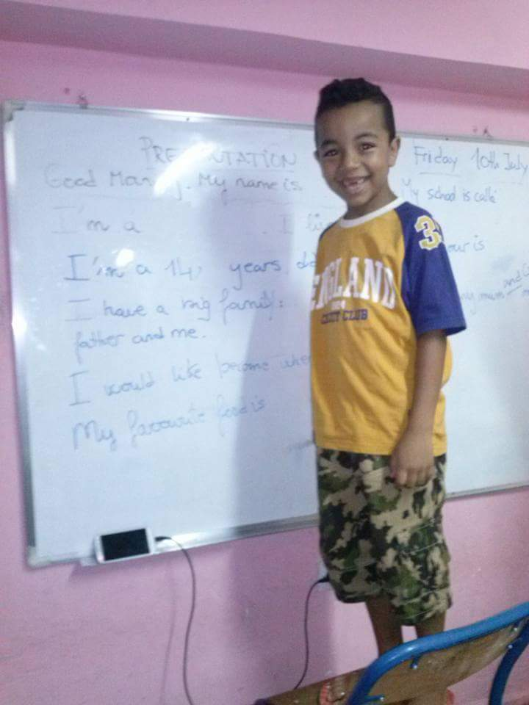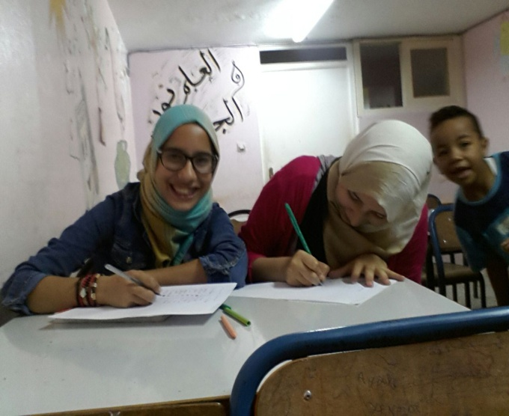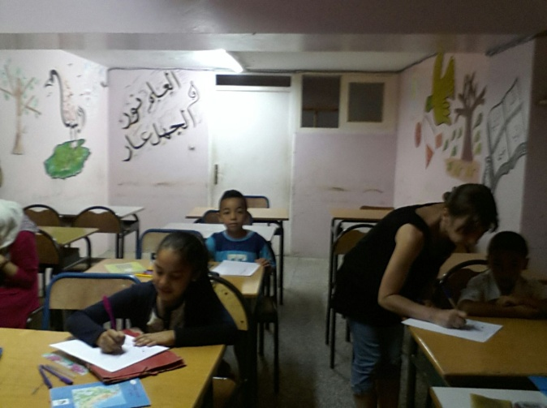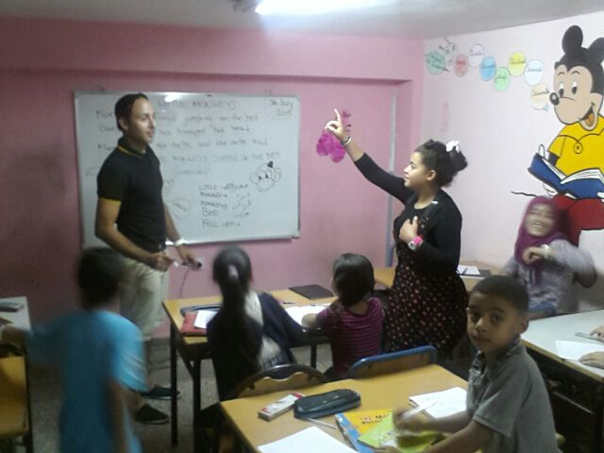

------------------------------------

**Chantiers Sociaux Marocains**

RP. : 456 Rabat RP. Maroc Tél./Fax : (212) 537 26 23 98 E-mail : csm_morocco@yahoo.fr

|  |
| --- |
| *VOLUNTARY WORK PLACEMENT* |

|  |  |
| --- | --- |
| **NAME OF THE PROJECT AND CODE** | **Volunteer for immigrants integration**  **CODE CSM82.6** |
| **LOCATION**  **COUNTRY**  **EMAIL**  **CONTACT PERSON** | RABAT    Contact person: + 212 655832272 HAMID  **Emergency contact :** + 212 617332316 |
| **PROJECT’S TOPIC** | Education and Integration support for immigrants and refugees in Morocco |
| **AIMS OF THE PROJECT** | Give the chance to immigrants and refugees currently in Morocco to master basic skills and improve their communication skills in order to encourage their integration and make it more likely for them to find a job. |
| **PROJECT’S ACTIVITIES** | • Teach communication classes  • Cultural activities  • Work camps  • Seminars |
| **COMMUNITY CONTEXT** | Geographically and figuratively speaking, Morocco is the “Door of Europe”. Each year many immigrants and refugees from southerner countries of Africa arrive illegally in the country and frequently get stuck for a while in bad living conditions. National programs exist to offer them educational, professional and cultural support reflecting the tradition of solidarity and hospitality that characterizes Morocco.  The international volunteers will work as a team with the national volunteers, therefore they will be able to observe and discover not only the immigrants’ way of life but also Moroccans’ habits and culture though practical and social involvement. This kind of project is usually very rewarding on a personal level for the volunteers because if their implication is genuine they will rapidly feel they are making a real change in the lives of the refugees whose only chance to get access to a better education is this type of program. By working closely with national volunteers, the international ones will have the opportunity to quickly develop ties with locals and get involved in the community not only at work but outside as well.  Fondation Orient-Occident (FOO) is a Moroccan non-profit organization recognized of public utility. Intellectually and practically conceived as a bridge between the two shores of the Mediterranean, its mission is to come towards the difficulties of migrants, refugees and the disadvantaged youth, and to promote employability by setting up socio-educational and professional training centers. Fondation Orient-Occident also works for the protection of diversity, and for the valorisation of all cultures. Nowadays the Foundation is present in several Moroccan cities, namely Rabat, Oujda, Casablanca, Larache, Safi, Youssoufia and Khouribga and in Italy. In addition, the Foundation carries out advocacy work at the international level, particularly in the framework of its participation to global meetings such as the World Economic Forum.  **Rabat** is the capital and fourth largest city of Morocco with an average population of 580,000 people. It combines both Mediterranean and Oceanic influences on many aspects. Rabat’s climate is mild and temperate, with cool winters and warm summer days. The city is quite dynamic as far as cultural activity is concerned thanks to many structures (Theatre Mohammed V right in the city centre, Cinema Renaissance, official galleries and the archaeological museum) and active associative work.  Further information about the country will be attached in the National Profile form. |
| **VOLUNTEER’S REQUIREMENTS** | • Have common sense and assertion  • Strong motivation  • Believe in cultural exchanges when it comes to promote peace and stability  • Be able to take initiative  • Flexibility, responsibility and patience  • Be willing to get involved in all the activities that they will carry out with the local volunteers: language support, cuisine workshops, support sports activities etc.  • At least a medium level of French is required for this project. |
| **VOLUNTEER’S TASKS** | • Non-formal teaching of French, English, basic math for the youngest, etc.  • Take part and/or organize sport activities and recreation programs.  • Promote the diversity of cultural expressions (try to organize once every 2 weeks a cultural activity)  The volunteers will be divided in two groups: some days one group will teach and the other will perform recreational activities and vice versa.  The volunteers will be able to take part in all the other activities that CSM and the national volunteers are already carrying out with immigrants and refugees (especially children and teenagers) in a center in Rabat that we have rented for that purpose. |
| **ACCOMMODATION DETAILS** | The volunteers will live in host families or shared apartments, depending on availability. Further information will be given in due time. |
| **ARRIVAL OPTIONS AND MEETING POINT** | • If you choose to arrive directly in Rabat Airport, we can arrange someone to pick you up for 150 dirhams, otherwise the meeting point will be Rabat Ville Train Station.  • To get to the Rabat Ville Train Station from the airport you can take the bus right outside the gate for 20 dirhams and it will leave you in front of the train station. With a taxi, it should cost you about 100 dirhams (price negotiable).  • If you arrive in any other airport of the country, you will be able to reach Rabat by train, check the timetable and connections on [www.oncf.ma](http://www.oncf.ma/)  Once you have your flights details please pass them by e-mail to your interlocutor so you can arrange with him/her the meeting point.  The info sheet will be send to you by e-mail 3 weeks prior departure. |

’Union Marocaine des Association des Chantiers

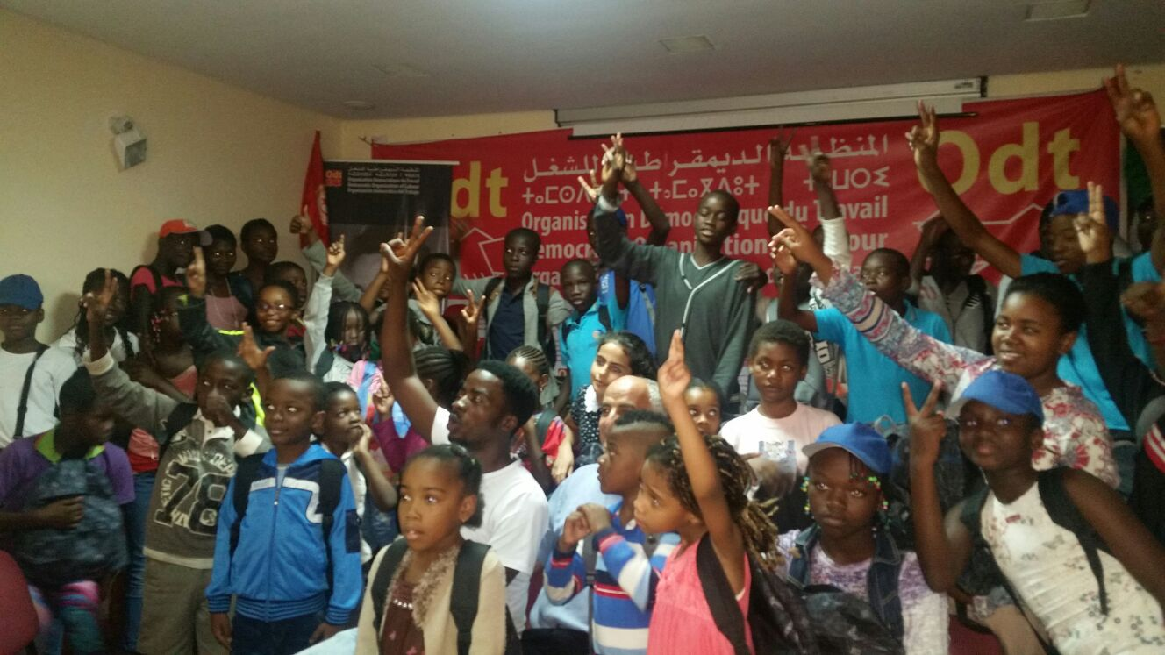

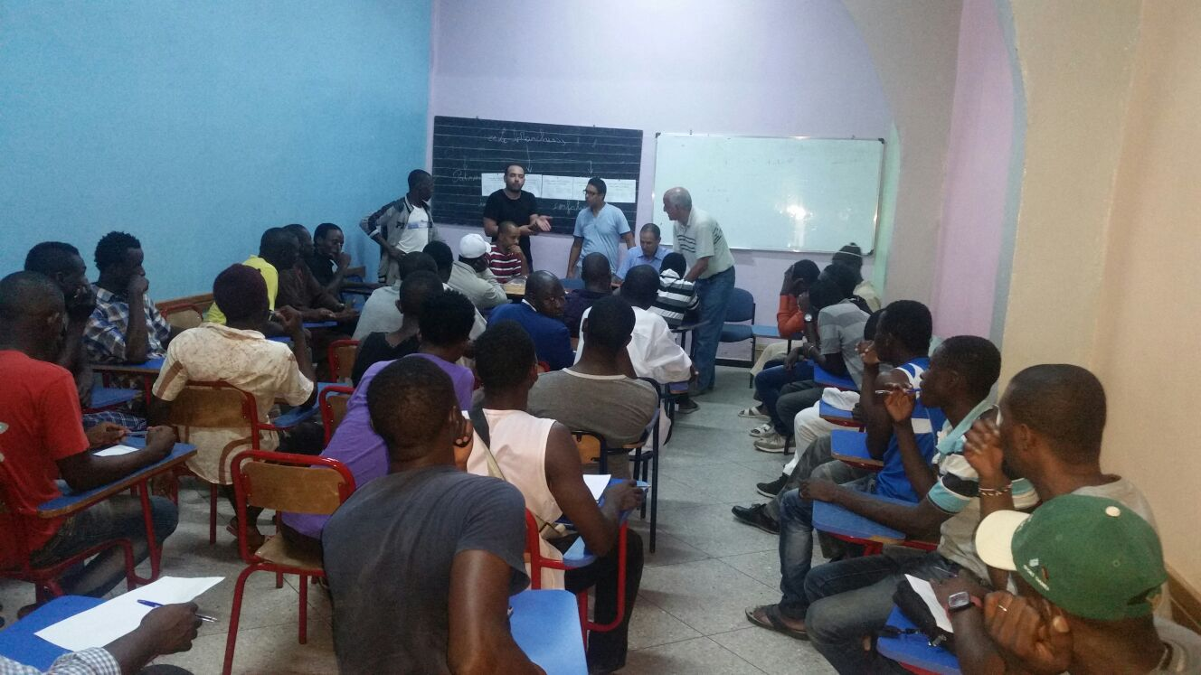



**Chantiers Sociaux Marocains**

RP. : 456 Rabat RP. Maroc Tél./Fax : (212) 537 26 23 98 E-mail : csm_morocco@yahoo.fr

|  |
| --- |
| *VOLUNTARY WORK PLACEMENT* |

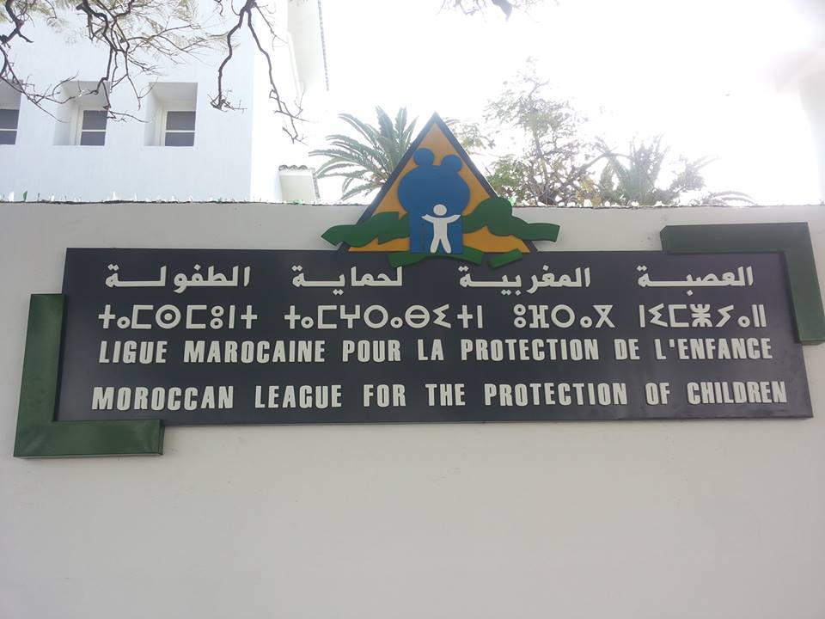

|  |  |
| --- | --- |
| **NAME OF THE PROJECT AND CODE** | **Children Welfare Center Lalla Meryem Center**  **CODECSM 83.7** |
| **LOCATION**  **ADDRESS**  **COUNTRY**  **PHONE/FAX**  **EMAIL**  **CONTACT PERSON** | Centre Lalla Meriem, Rabat  Contact person central office: + 212 655832272 HAMID  **Emergency contact :** + 212 617332316 |
| **PROJECT’S TOPIC** | Children with disabilities and Orphans |
| **AIMS OF THE PROJECT** | The center Lalla Meryem is part of the Moroccan League for the protection of children. They host orphan children from their birth until the age of 6 years old. Some mothers bring them and leave them there because of their personal situations and the children stay there until the center finds the right host family for them. They also host some children that people found abandoned in the street and took them to the center. Those who are handicapped often stay there until they die and the center takes care of them until then.    They can host up to 200 children, although there are currently 123, among them 50 are handicapped. They suffer from IMC, trisomy 21 or down syndrome, motor handicaps - some of them are in wheelchairs - or mental disabilities that keeps them from having a normal life, like autism.  They all benefit from specialized social workers and doctors who work in the center to provide them the right assistance.    The orphans in the center benefit from a social, medical and educational follow-up in Rabat public and private schools (their education starts at the age of 3 years old, before that there are nurses in the school who feed them and take care of their general needs). |
| **PROJECT’S ACTIVITIES** | With disabled children: Help them with everyday life tasks: taking showers, taking them for a walk, preparing their meals, etc. Social workers are here to carry out these tasks. They are specialized in particular disabilities: how they affect them, how they are treated and what to do in any case.  With the orphans:  • Procedures of adoption  • Circumcision  • Feed the babies  • Organize outdoors activities |
| **COMMUNITY CONTEXT** | The center hosts several disabled children or children in very difficult situations therefore the volunteers will take part and observe their everyday life habits and culture through practical and social involvement. They will get in touch with national volunteers and social workers in the center, which give them the opportunity to get involved in the community, not only inside the center but also outside, when they finish work.  **Rabat** is the capital and fourth largest city of Morocco with an average population of 580,000 people. It combines both Mediterranean and Oceanic influences on many aspects. Rabat’s climate is mild and temperate, with cool winters and warm summer days. The city is quite dynamic as far as cultural activity is concerned thanks to many structures (Theatre Mohammed V right in the city centre, Cinema Renaissance, official galleries and the archaeological museum) and active associative work.  Further information about the country will be attached in the National Profile form. |
| **VOLUNTEER’S REQUIREMENTS** | • No previous working experience required.  • Enthusiastic, positive, patient and respectful people needed.  • People psychologically prepared to work with children suffering various disabilities.  • Willingness to develop ties with other nationalities and learn new things, of course we encourage everyone to follow the pace they feel comfortable with. |
| **VOLUNTEER’S TASKS** | The volunteers will be able to participate in all the activities of the center:  • Assist the professionals in their daily tasks (Shower the kids, walk them around, prepare meals, etc.). This would be a good way to learn the job as the social worker will be here to answer all the questions and train the interested volunteers.  • Help with feeding the babies and carry out the outdoors activities  • Learn about procedures of adoption and circumcision in order to be able to give extra help in the matter in case of need.  • Take initiative and propose activities/workshops (f.e music, painting, etc.)  The volunteers will never perform any task alone, always under the supervision of a social worker. |
| **ACCOMMODATION**  **DETAILS** | Volunteers will live in host families where they will be given 3 meals per day. Further information will be given in due time. |
| **ARRIVAL OPTIONS AND MEETING POINT** | • If you choose to arrive directly in Rabat Airport, we can arrange someone to pick you up for 150 dirhams, otherwise the meeting point will be Rabat Ville Train Station.  • To get to the Rabat Ville Train Station from the airport you can take the bus right outside the gate for 20 dirhams and it will leave you in front of the train station. With a taxi, it should cost you about 100 dirhams (price negotiable).  • If you arrive in any other airport of the country, you will be able to reach Rabat by train, check the timetable and connections on [www.oncf.ma](http://www.oncf.ma/)  Once you have your flights details please pass them by e-mail to your interlocutor so you can arrange with him/her the meeting point.  The info sheet will be send to you by e-mail 3 weeks prior departure. |

----------------------------

**Chantiers Sociaux Marocains**

RP. : 456 Rabat RP. Maroc Tél./Fax : (212) 537 26 23 98 E-mail : csm_morocco@yahoo.fr

|  |
| --- |
| *VOLUNTARY WORK PLACEMENT* |

|  |  |
| --- | --- |
| **NAME OF THE PROJECT AND CODE** | **ABNAOUNA (Our children)**  **CODE CSM85.9** |
| **LOCATION**  **ADDRESS**  **COUNTRY**  **PHONE/FAX**  **EMAIL**  **CONTACT PERSON** | MARRAKESH    Contact person central office: + 212 655832272 HAMID  **Emergency contact :** + 212 617332316 |
| **PROJECT’S TOPIC** | Assist children with down syndrome |
| **AIMS OF THE PROJECT** | The objective of this project is to work for the integration of children with down syndrome and help them master basic useful skills, teach them social manners and encourage their social integration (through scholar support and cultural activities) to ensure them a life as ordinary as possible. |
| **PROJECT’S ACTIVITIES** | The center has the capacity to welcome 40 children with down syndrome but only half of them are attending classes because of a lack of transport.  The daily activities are:  • Take care of down syndrome children and accompany them in their daily tasks  • Organize leisure activities  • Support the teachers by helping to teach them manners: how to sit down, how to eat, etc.  • Provide them scholar support in a school where all kind of children attend classes and encourage their integration with the other kids.  • Organize workshops: Painting – Sport – Cooking – Literacy – Music – Outdoors excursions, etc.  • Develop self-appreciation in the heart of the children through a skill-based approach.  Just in front of the center, there is a medical center where the children get follow-up for psychological issues, physiotherapy, speech therapy...  The staff of this association is mostly composed of parents who were interested in giving children in this situation a better life based on integration. |
| **COMMUNITY CONTEXT** | The center hosts several children with trisomy 21 and the volunteers will take part in their everyday life habits and discover aspect of the Moroccan culture through practical and social involvement. They will get in touch with national volunteers and social workers in the center, which give them the opportunity to get involved in the community, not only inside the center but also outside, when they finish work.  **Marrakech** is the capital of the mid-south-western region of Morocco called “Marrakesh-Asfi”. It owes it nickname “Red city” or “Ochre city” to its red sandstone building walls. It is among the 5 biggest cities of the country and benefits from a hot semi-arid climate (about 12°C in winter and 32 to 45°C in summer).  The Jemma El-Fnaa is one of the most famous squares of Africa and is the city’s activity and trade center. Snake charmers, acrobats, magicians, musicians, monkey trainers, herb sellers, storytellers, dentists, pickpockets and entertainers in medieval garb still abound in the square.  Marrakesh hosts many national and Islamic festivals including the National Folklore Festival, the Berber Festival and the International Film Festival of Marrakesh, which aspires to be the North African version of Cannes.  The best way to explore the streets and alleyways of the city is to dive in and get lost. Check out for the dotted signs that will point you back to the Dejeema el Fna and don’t hesitate to seek help from locals. If you let them walk you to a place they might ask you for money, in that case no problem you can politely decline, but if they did take you to a nice place you would ordinarily miss it doesn’t hurt to give away 10 or 20 dirhams (1 or 2 euros).  Keep in mind that **bargaining** is a huge part of the Moroccan culture; don’t be afraid to do it. When you get used to it, it’s a very nice and fun way to start a conversation with locals and learn more about their way of life.  Further information about the country will be attached in the National Profile form. |
| **VOLUNTEER’S REQUIREMENTS** | • No previous working experience required.  • Enthusiastic, positive, patient and respectful people needed.  • People psychologically prepared to work with children suffering various disabilities.  • Willingness to develop ties with other nationalities and learn new things, of course we encourage everyone to follow the pace they feel comfortable with. |
| **VOLUNTEER’S TASKS** | The center is open from 8am to 5pm. They expect volunteers to:  • Take care of the children and accompany them in their daily tasks.  • Organize leisure activities of children with Down Syndrome (artistic activities, sport sessions, etc.)  • Help the teachers and social workers out in teaching the children manners: how to eat, how to behave in public etc.  • Provide scholar support in a creative way (with games, songs, etc.)  • Help in the kitchen for breakfast and lunch preparation |
| **ACCOMMODATION DETAILS** | The volunteers can choose between living with a host family or sharing a flat with other volunteers. |
| **ARRIVAL OPTIONS AND MEETING POINT** | Marrakech train station is the ideal meeting point.  Marrakesh airport has a lot of flight connections from all over the world. Otherwise, you can fly from any other city and take a train. You can check the train timetables on the ONCF website: <http://www.oncf.ma/>  From the Airport to the train station, you can take a **bus** or a **taxi**. **Please remember you can only pay in dirhams, the local currency so don’t forget to change money inside the airport**.  There is a special airport bus (number 19) that departs right from the outside of the airport.  As for the taxis, they are a good option but you would have to deal the price beforehand. The normal price is 100 Dirhams.  Once you have your flights details please pass them by e-mail to your interlocutor so you can arrange with him/her the meeting point.  The info sheet will be send to you by e-mail 3 weeks prior departure. |

----------------------------

**Chantiers Sociaux Marocains**

RP. : 456 Rabat RP. Maroc Tél./Fax : (212) 537 26 23 98 E-mail : csm_morocco@yahoo.fr

|  |
| --- |
| *VOLUNTARY WORK PLACEMENT* |

|  |  |
| --- | --- |
| **NAME OF THE PROJECT AND CODE** | **AMSEI (Moroccan Association of Support for Non-adapted Children)**  **CODE CSM86.10** |
| **LOCATION**  **ADDRESS**  **COUNTRY**  **PHONE/FAX**  **EMAIL**  **CONTACT PERSON** | Centre AL BASMA MOROCCO  Contact person central office: + 212 655832272 HAMID  **Emergency contact :** + 212 617332316 |
| **PROJECT’S TOPIC** | Assist children with heavy disabilities or important integration difficulties |
| **AIMS OF THE PROJECT** | The objective of this project is to provide children with heavy disabilities and important integration difficulties with personalized educative and medical follow up in order to help them build their own life project and have a life as ordinary and autonomous as possible. |
| **PROJECT’S ACTIVITIES** | The AMSEI asociation opened a center called AL BASMA where they welcome children from 4 to 20 years old during the day, propose them a diversified range of activities and take charge of their medical needs.  AMSEI also put in place “integrated classes” in partnership with public schools where they provide individual support to kids that are able to attend regular classes.  Concrete activities of the association:  • Organize educative, sportive, artistic, manual and cultural activities with the children.  • Life council and regular meetings with the families to orient the kids toward adapted activities.  • Medical support and follow-up of the children.  The children are divided into 4 age groups: 4 to 7, 8 to 11, 12 to 16, 17 to 20.  • With the younger groups, the main focus is personal development, socialization and scholar integration.  • With the oldest groups, the main focus is the development of lucrative activities and socio-professional integration.  • With the kids who suffer from heavy and cumulated disabilities, the main focus is the development of their sensorial skills and autonomy and socialization skills. |
| **COMMUNITY CONTEXT** | The staff of the project is composed of health professionals, psychologists, physiotherapists, specialized educators, etc. working closely with the administrative staff, the families and the volunteers.  By working in this centre, the international volunteers will be in contact with many locals and will have the opportunity to get to know Moroccan’s habits and ways of life and get involved in the community at work as well as on their spare-time.  **Rabat** is the capital and fourth largest city of Morocco with an average population of 580,000 people. It combines both Mediterranean and Oceanic influences on many aspects. Rabat’s climate is mild and temperate, with cool winters and warm summer days. The city is quite dynamic as far as cultural activity is concerned thanks to many structures (Theatre Mohammed V right in the city centre, Cinema Renaissance, official galleries and the archaeological museum) and active associative work. |
| **VOLUNTEER’S REQUIREMENTS** | • No previous working experience required.  • Enthusiastic, positive, dynamic, patient and respectful people needed.  • Medium level of French and/or English required.  • People psychologically prepared to work with children suffering various disabilities.  • Willingness to develop ties with other nationalities and learn new things, of course we encourage everyone to follow the pace they feel comfortable with. |
| **VOLUNTEER’S TASKS** | • About 4 hours of work per day from Monday to Friday  • Take care of the children and accompany them in their daily tasks.  • Assist the realization of leisure activities (educative, sportive, artistic activities, etc.)  • Help in the kitchen  • Provide scholar support in a creative way (with games, songs, etc.)  If the volunteers have any knowledge and/or interest in the matter, they can assist the paramedical staff. |
| **ACCOMMODATION DETAILS** | The volunteers will live with host families where they will be given 3 meals per day. Further information will be given in due time. |
| **ARRIVAL OPTIONS AND MEETING POINT** | • If you choose to arrive directly in Rabat Airport, we can arrange someone to pick you up for 150 dirhams, otherwise the meeting point will be Rabat Ville Train Station.  • To get to the Rabat Ville Train Station from the airport you can take the bus right outside the gate for 20 dirhams and it will leave you in front of the train station. With a taxi, it should cost you about 100 dirhams (price negotiable).  • If you arrive in any other airport of the country, you will be able to reach Rabat by train, check the timetable and connections on [www.oncf.ma](http://www.oncf.ma/)  Once you have your flights details please pass them by e-mail to your interlocutor so you can arrange with him/her the meeting point.  The info sheet will be send to you by e-mail 3 weeks prior departure. |

----------------------------

**Chantiers Sociaux Marocains**

RP. : 456 Rabat RP. Maroc Tél./Fax : (212) 537 26 23 98 E-mail : csm_morocco@yahoo.fr

|  |
| --- |
| *VOLUNTARY WORK PLACEMENT* |

|  |  |
| --- | --- |
| **NAME OF THE PROJECT AND CODE** | **CSPA (Social Center for Elderly People)**  **CODE CSM87.11** |
| **LOCATION**  **ADDRESS**  **COUNTRY**  **PHONE/FAX**  **EMAIL**  **CONTACT PERSON** | Centre Social pour Personnes Âgées, RABAT MOROCCO  Contact person central office: + 212 655832272 HAMID  **Emergency contact :** + 212 617332316 |
| **PROJECT’S TOPIC** | Take care of elder persons in situation of deep poverty and social exclusion. |
| **AIMS OF THE PROJECT** | The objective of this project is to provide decent living condition to elder people in situation of deep poverty and social exclusion or isolation (homeless and without family support), fight against elder’s mendicancy and encourage their socioeconomic insertion. |
| **MORE INFO ABOUT THE PROJECT** | This elder people home hosts about 40 elders (60 and +) and offers them accommodation, restoration, medical follow-up and protection.  Actions:  • Organize different activities in order to encourage social cohesion and integration.  • Provide them with legal assistance/council.  • Give orientation advice and help the development of lucrative activities.  • Rise awareness about elder’s mendicancy  Ambitions:  • Extend the project to other poverty-striken region  • Create a “Regional observatory of elder people precariousness” and develop a database and monograph of elder peolpe assistance |
| **COMMUNITY CONTEXT** | By working in this centre, the international volunteers will be in contact with many locals and will have the opportunity to get to know Moroccan’s habits and ways of life and get involved in the community at work as well as on their spare-time.  **Rabat** is the capital and fourth largest city of Morocco with an average population of 580,000 people. It combines both Mediterranean and Oceanic influences on many aspects. Rabat’s climate is mild and temperate, with cool winters and warm summer days. The city is quite dynamic as far as cultural activity is concerned thanks to many structures (Theatre Mohammed V right in the city centre, Cinema Renaissance, official galleries and the archaeological museum) and active associative work. |
| **VOLUNTEER’S REQUIREMENTS** | • No previous working experience required.  • Enthusiastic, positive, dynamic, patient and respectful people needed.  • Medium level of French and/or English required.  • Willingness to develop ties with other nationalities and learn new things, of course we encourage everyone to follow the pace they feel comfortable with. |
| **VOLUNTEER’S TASKS** | • About 4 hours of work per day from Monday to Friday  • Take care of the elder people and accompany them in their daily tasks.  • Assist the realization of leisure activities and workshops  If the volunteers have any knowledge and/or interest in the matter, they can assist the paramedical staff. |
| **ACCOMMODATION DETAILS** | The volunteers will live with host families where they will be given 3 meals per day. Further information will be given in due time. |
| **ARRIVAL OPTIONS AND MEETING POINT** | • If you choose to arrive directly in Rabat Airport, we can arrange someone to pick you up for 150 dirhams, otherwise the meeting point will be Rabat Ville Train Station.  • To get to the Rabat Ville Train Station from the airport you can take the bus right outside the gate for 20 dirhams and it will leave you in front of the train station. With a taxi, it should cost you about 100 dirhams (price negotiable).  • If you arrive in any other airport of the country, you will be able to reach Rabat by train, check the timetable and connections on [www.oncf.ma](http://www.oncf.ma/)  Once you have your flights details please pass them by e-mail to your interlocutor so you can arrange with him/her the meeting point.  The info sheet will be send to you by e-mail 3 weeks prior departure. |

----------------------------

**Chantiers Sociaux Marocains**

RP. : 456 Rabat RP. Maroc Tél./Fax : (212) 537 26 23 98 E-mail : csm_morocco@yahoo.fr

|  |
| --- |
| *VOLUNTARY WORK PLACEMENT* |

|  |  |
| --- | --- |
| **NAME OF THE PROJECT AND CODE** | **HADAF**  **CODE CSM90.14** |
| **LOCATION**  **ADDRESS**  **COUNTRY**  **PHONE/FAX**  **EMAIL**  **CONTACT PERSON** | RABAT MOROCCO  Contact person central office: + 212 655832272 HAMID  **Emergency contact :** + 212 654482151 |
| **PROJECT’S TOPIC** | Help young people presenting mental disorders to live a life as ordinary and autonomous as possible. |
| **AIMS OF THE PROJECT** | The objective of this project is to provide people suffering mental disorders a comfortable environment and offer them perspective of personal development and professional insertion. |
| **MORE INFO ABOUT THE PROJECT** | Hadaf is an associative socio-professional center designed for young people presenting mild mental disorders whether they have been previously followed by a medico-pedagogic institute or not. Its main goal is to offer them a comfortable environment ideal for their personal development and professional insertion.  The center currently hosts about 80 young people and has a staff of about 20 members. The center works tightly with the families and presents itself as a place where the young, the families and the professionals can meet and discuss and share. The facilities are modern and environment friendly.  The Hadaf center offers an individual follow-up for each young disabled person and orients him or her to specific trainings/workshops that suits him/her best. They propose artistic workshops and professional training (for example in restoration). They often expose and sell products made by the young persons to foster their professional initiative and motivation and the profits can be used to improve the propositions of the center. |
| **COMMUNITY CONTEXT** | The staff of the project is composed of health professionals, psychologists, physiotherapists, specialized educators, etc. working closely with the administrative staff, the families and the volunteers. The cultivation of a real sense of community is important to the Hadaf center.  By working in this centre, the international volunteers will be in contact with many locals and will have the opportunity to get to know Moroccan’s habits and ways of life and get involved in the community at work as well as on their spare-time.  **Rabat** is the capital and fourth largest city of Morocco with an average population of 580,000 people. It combines both Mediterranean and Oceanic influences on many aspects. Rabat’s climate is mild and temperate, with cool winters and warm summer days. The city is quite dynamic as far as cultural activity is concerned thanks to many structures (Theatre Mohammed V right in the city centre, Cinema Renaissance, official galleries and the archaeological museum) and active associative work. |
| **VOLUNTEER’S REQUIREMENTS** | • No previous working experience required.  • Enthusiastic, positive, dynamic, patient and respectful people needed.  • Medium level of French and/or English required.  • Be psychologically prepared to work with disabled persons.  • Willingness to develop ties with other nationalities and learn new things, of course we encourage everyone to follow the pace they feel comfortable with. |
| **VOLUNTEER’S TASKS** | • About 4 hours of work per day from Monday to Friday  • Participate in the everyday running of the association  • The volunteers can ask to work on any of the different activities and sections of the association, and if they express any preferences they will be oriented to where there is need of extra hands.  • Assist the realization of leisure activities and workshops  If the volunteers have any knowledge and/or interest in the matter, they can assist the paramedical staff. |
| **ACCOMMODATION DETAILS** | The volunteers will live with host families where they will be given 3 meals per day. Further information will be given in due time. |
| **ARRIVAL OPTIONS AND MEETING POINT** | • If you choose to arrive directly in Rabat Airport, we can arrange someone to pick you up for 150 dirhams, otherwise the meeting point will be Rabat Ville Train Station.  • To get to the Rabat Ville Train Station from the airport you can take the bus right outside the gate for 20 dirhams and it will leave you in front of the train station. With a taxi, it should cost you about 100 dirhams (price negotiable).  • If you arrive in any other airport of the country, you will be able to reach Rabat by train, check the timetable and connections on [www.oncf.ma](http://www.oncf.ma/)  Once you have your flights details please pass them by e-mail to your interlocutor so you can arrange with him/her the meeting point.  The info sheet will be send to you by e-mail 3 weeks prior departure. |

----------------------------

**Chantiers Sociaux Marocains**

RP. : 456 Rabat RP. Maroc Tél./Fax : (212) 537 26 23 98 E-mail : csm_morocco@yahoo.fr

|  |
| --- |
| *VOLUNTARY WORK PLACEMENT* |

|  |  |
| --- | --- |
| **NAME OF THE PROJECT AND CODE** | **JOSSOUR FFM (Moroccan Women Forum)**  **CODE CSM91.15** |
| **LOCATION**  **ADDRESS**  **COUNTRY**  **PHONE/FAX**  **EMAIL**  **CONTACT PERSON** | RABAT MOROCCO  Contact person central office: + 212 655832272 HAMID  **Emergency contact :** + 212 617332316 |
| **PROJECT’S TOPIC** | Promote Women’s rights |
| **AIMS OF THE PROJECT** | The objective of this project is to promote women’s rights and women empowering through the education of the citizens and the valorization of women. The association provides training and legal advice for women and holds conferences and several manifestations to discuss and advocate women’s rights. |
| **MORE INFO ABOUT THE PROJECT** | Jossour FFM is a Moroccan association that fights for women equality and women empowering. Their wish is to strengthen the concept of citizenship and women rights in developing societies especially North Africans. In 2014, the association wad granted the status of ECOSOC consultant for its efforts and realizations in favour of women rights in Morocco. Since then, Jossour FFM can therefore participate in UN sessions and meetings and discuss its preoccupation with the international community.  The main objectives of this association are:  • Offering alphabetization and foreign language education  • Opening the debate on women’s rights  • Giving media coverage to women  • Raising awareness among the community  • Training the new generation on advocacy strategies  • Producing researches and publications of women’s questions on a national and international scale  Since the creation of their Center of Citizenship in 1995, 2160 women benefitted from their training programs. In the center, the association proposes 2 different levels of alphabetization courses in partnership with Ministry of National Education and Professional Training, workshops about citizenship and equality (civic, social, politic, economic and professional) values and round tables about the Family Code, advocacy strategies, the Constitution, etc. The center also organizes visits of public institutions for the members, and the last Friday of every month, experts, lawyers, militants and coaches are invited to discuss citizenship.  The center is about to start a new project financed by the APEFE called “Minajliki” that will implement cycles of social entrepreneurship training for women. |
| **COMMUNITY CONTEXT** | By working in this centre, the international volunteers will be in contact with many locals and will have the opportunity to get to know Moroccan’s habits and ways of life and get involved in the community at work as well as on their spare-time.  **Rabat** is the capital and fourth largest city of Morocco with an average population of 580,000 people. It combines both Mediterranean and Oceanic influences on many aspects. Rabat’s climate is mild and temperate, with cool winters and warm summer days. The city is quite dynamic as far as cultural activity is concerned thanks to many structures (Theatre Mohammed V right in the city centre, Cinema Renaissance, official galleries and the archaeological museum) and active associative work. |
| **VOLUNTEER’S REQUIREMENTS** | • No previous working experience required.  • Enthusiastic, positive, dynamic, patient and respectful people needed.  • Medium level of French and/or English required.  • Willingness to develop ties with other nationalities and learn new things, of course we encourage everyone to follow the pace they feel comfortable with. |
| **VOLUNTEER’S TASKS** | • About 4 hours of work per day from Monday to Friday  • Participate in the everyday running of the association  • The volunteers can ask to work on any of the different activities and sections of the association, and if they express any preferences they will be oriented to where there is need of extra hands.  • Assist the realization of leisure activities and workshops |
| **ACCOMMODATION DETAILS** | The volunteers will live with host families where they will be given 3 meals per day. Further information will be given in due time. |
| **ARRIVAL OPTIONS AND MEETING POINT** | • If you choose to arrive directly in Rabat Airport, we can arrange someone to pick you up for 150 dirhams, otherwise the meeting point will be Rabat Ville Train Station.  • To get to the Rabat Ville Train Station from the airport you can take the bus right outside the gate for 20 dirhams and it will leave you in front of the train station. With a taxi, it should cost you about 100 dirhams (price negotiable).  • If you arrive in any other airport of the country, you will be able to reach Rabat by train, check the timetable and connections on [www.oncf.ma](http://www.oncf.ma/)  Once you have your flights details please pass them by e-mail to your interlocutor so you can arrange with him/her the meeting point.  The info sheet will be send to you by e-mail 3 weeks prior departure. |

----------------------------

**Chantiers Sociaux Marocains**

RP. : 456 Rabat RP. Maroc Tél./Fax : (212) 537 26 23 98 E-mail : csm_morocco@yahoo.fr

|  |
| --- |
| *VOLUNTARY WORK PLACEMENT* |

|  |  |
| --- | --- |
| **NAME OF THE PROJECT AND CODE** | **ADAN**  **CODE CSM92.16** |
| **LOCATION**  **ADDRESS**  **COUNTRY**  **PHONE/FAX**  **EMAIL**  **CONTACT PERSON** | RABAT MOROCCO    Contact person central office: + 212 655832272 HAMID  **Emergency contact :** + 212 617332316 |
| **PROJECT’S TOPIC** | Taking care for street animals |
| **AIMS OF THE PROJECT** | This assosiation wants to improve the situation of street animals in Morocco. That means on the one hand taking care for animals , that are still living on the street to offer them food and medical care and on the other hand it means to do prevention work to sensitize locals for this subject and to achieve an improvement oft he situation also in the long run. |
| **MORE INFO ABOUT THE PROJECT** | The work of this assosiation includes caretaking of streetanimals, like feed them, give them medical care and to find a nice new home fort hem as well as prevention work, like informing locals about the topics inoculation and castration and sterilizaton. They also senitize people for their dealings with hygiene,to get the hang oft he problems with rats in the city. And there have recently been attemps to inform about new forms of therapy with animals.  , summits, workshops, seminars, etc.)  The association has opened a leather workshop where they offer profesional training and are implementing alphabetization classes. They are also currently opening a center of formation and information as well as a cultural center. |
| **COMMUNITY CONTEXT** | By working with this association, the international volunteers will be in contact with many locals and will have the opportunity to get to know Moroccan’s habits and ways of life and get involved in the community at work as well as on their spare-time.  **Rabat** is the capital and fourth largest city of Morocco with an average population of 580,000 people. It combines both Mediterranean and Oceanic influences on many aspects. Rabat’s climate is mild and temperate, with cool winters and warm summer days. The city is quite dynamic as far as cultural activity is concerned thanks to many structures (Theatre Mohammed V right in the city centre, Cinema Renaissance, official galleries and the archaeological museum) and active associative work. |
| **VOLUNTEER’S REQUIREMENTS** | No specific previous experience needed, but the volunteer should be used to the handling with animals and he/she should not have a fear of contact with them. Some creative abilities would be useful fort he public relation work. |
| **VOLUNTEER’S TASKS** | The volunteers will help the workers in taking care fort he animals, like going to veterinary surgeon with them, feed them, etc. And they will support the assosiation to organize certain actions of public realition work. |
| **ACCOMMODATION DETAILS** | The volunteers will live with host families where they will be given 3 meals per day. Further information will be given in due time. |
| **ARRIVAL OPTIONS AND MEETING POINT** | • If you choose to arrive directly in Rabat Airport, we can arrange someone to pick you up for 150 dirhams, otherwise the meeting point will be Rabat Ville Train Station.  • To get to the Rabat Ville Train Station from the airport you can take the bus right outside the gate for 20 dirhams and it will leave you in front of the train station. With a taxi, it should cost you about 100 dirhams (price negotiable).  • If you arrive in any other airport of the country, you will be able to reach Rabat by train, check the timetable and connections on [www.oncf.ma](http://www.oncf.ma/)  Once you have your flights details please pass them by e-mail to your interlocutor so you can arrange with him/her the meeting point.  The info sheet will be send to you by e-mail 3 weeks prior departure. |

----------------------------

**Chantiers Sociaux Marocains**

RP. : 456 Rabat RP. Maroc Tél./Fax : (212) 537 26 23 98 E-mail : csm_morocco@yahoo.fr

|  |
| --- |
| *VOLUNTARY WORK PLACEMENT* |

|  |  |
| --- | --- |
| **NAME OF THE PROJECT AND CODE** | **HOSPITAL OF CHILDREN**  **CODE CSM93.17** |
| **LOCATION**  **ADDRESS**  **COUNTRY**  **PHONE/FAX**  **EMAIL**  **CONTACT PERSON** | RABAT MOROCCO    Contact person central office: + 212 655832272 HAMID  **Emergency contact :** + 212 617332316 |
| **PROJECT’S TOPIC** | Working in an hospital in the childrens department (paediatric department) |
| **AIMS OF THE PROJECT** | This assosiation wants to offer partly seriously ill children a psychological help besides their medical treatment. With their work, existing out of love and care, they want to help the children to achieve their convalescence faster. Because only in an enviroment where the children feel well, they can get well. The hospital can not do this alone, so this assosiation can offer the children and their families special psychological support. |
| **MORE INFO ABOUT THE PROJECT** | First of all this work is for making the stay oft he children as pleasant as possible. This includes little actions like doing handicrafts,singing songs together, playing games or sometimes even just listening and give them love and care. Every Friday the children, their families and the workers enjoy couscous together. Sometimes this assosiation organizes even different actions, for example a big breakfast and donate clothes in a womans prison. They also make an effort in medical care for refugees. |
| **COMMUNITY CONTEXT** | By working with this association, the international volunteers will be in contact with many locals and will have the opportunity to get to know Moroccan’s habits and ways of life and get involved in the community at work as well as on their spare-time.  **Rabat** is the capital and fourth largest city of Morocco with an average population of 580,000 people. It combines both Mediterranean and Oceanic influences on many aspects. Rabat’s climate is mild and temperate, with cool winters and warm summer days. The city is quite dynamic as far as cultural activity is concerned thanks to many structures (Theatre Mohammed V right in the city centre, Cinema Renaissance, official galleries and the archaeological museum) and active associative work. |
| **VOLUNTEER’S REQUIREMENTS** | No specific previous experience needed, but the volunteer should be open minded and interested in working with children. Some creative abilities would be helpful and also the volunteer should not bee too highly-strung, because he/she may be confronted with cruel fates.  . |
| **VOLUNTEER’S TASKS** | The main work fort he volunteers will be in the hospital to support the therapists. This supoort includes planning and doing little games or songs with the children, or for example helping with the common lunch. If asked, the volunteer can also help to organize the little actions outside the hospital. |
| **ACCOMMODATION DETAILS** | The volunteers will live with host families where they will be given 3 meals per day. Further information will be given in due time. |
| **ARRIVAL OPTIONS AND MEETING POINT** | • If you choose to arrive directly in Rabat Airport, we can arrange someone to pick you up for 150 dirhams, otherwise the meeting point will be Rabat Ville Train Station.  • To get to the Rabat Ville Train Station from the airport you can take the bus right outside the gate for 20 dirhams and it will leave you in front of the train station. With a taxi, it should cost you about 100 dirhams (price negotiable).  • If you arrive in any other airport of the country, you will be able to reach Rabat by train, check the timetable and connections on [www.oncf.ma](http://www.oncf.ma/)  Once you have your flights details please pass them by e-mail to your interlocutor so you can arrange with him/her the meeting point.  The info sheet will be send to you by e-mail 3 weeks prior departure. |

**Chantiers Sociaux Marocains**

RP. : 456 Rabat RP. Maroc Tél./Fax : (212) 537 26 23 98 E-mail : csm_morocco@yahoo.fr

|  |
| --- |
| *VOLUNTARY WORK PLACEMENT* |

|  |  |
| --- | --- |
| **NAME OF THE PROJECT AND CODE** | **Moroccan Association for youth education.**  **CODE CSM93.17** |
| **LOCATION**  **ADDRESS**  **COUNTRY**  **PHONE/FAX**  **EMAIL**  **CONTACT PERSON** | RABAT MOROCCO    **Contact person central office:** + 212 655832272 HAMID  **Emergency contact :** + 212 617332316  **Address:** Avenue Hassan 2 197 Rabat, Morocco |
| **PROJECT’S TOPIC** | Working in an association for youth and women education. |
| **AIMS OF THE PROJECT** | This assosiation wants to offer annual formation and management trainings from which of youth get benefit. It organizes various weekly activities for children in different branches. Since 1961, the association has organized summer meeting for its friends – Growns ups – AMEJ organises nationwide and symposium, lectures and shows all throughout the year. It also organizes cultural, technical and formation and training, as well as daily and seasonale trips to some parts of Morocco the organization work with women and support them the volunteers will also atend some activities with women like cooking classes,informatique . |
| **MORE INFO ABOUT THE PROJECT** | First of all this work is for making the stay oft he children as pleasant as possible. This includes little actions like doing handicrafts,singing songs together, playing games or sometimes even just listening and give them love and care. As well as organizing summer camps, and weekly activities with the aim of educating and forming youth. AMEJ covers all ccities and regions in Morocco. |
| **COMMUNITY CONTEXT** | By working with this association, the international volunteers will be in contact with many locals and will have the opportunity to get to know Moroccan’s habits and ways of life and get involved in the community at work as well as on their spare-time.  **Rabat** is the capital and fourth largest city of Morocco with an average population of 580,000 people. It combines both Mediterranean and Oceanic influences on many aspects. Rabat’s climate is mild and temperate, with cool winters and warm summer days. The city is quite dynamic as far as cultural activity is concerned thanks to many structures (Theatre Mohammed V right in the city centre, Cinema Renaissance, official galleries and the archaeological museum) and active associative work. |
| **VOLUNTEER’S REQUIREMENTS** | No specific previous experience needed, but the volunteer should be open minded and interested in working with children. Some creative abilities would be helpful and also the volunteer should not bee too highly-strung, because he/she may be confronted with cruel fates.  . |
| **VOLUNTEER’S TASKS** | The main work for the volunteers will be in the association, schools to support children and women. This supoort includes planning and doing little games or songs with the children and teaching language for women , or for example helping with the common lunch. If asked, the volunteer can also help to organize the little actions outside. |
| **ACCOMMODATION DETAILS** | The volunteers will live with host families where they will be given 3 meals per day. Further information will be given in due time. |
| **ARRIVAL OPTIONS AND MEETING POINT** | • If you choose to arrive directly in Rabat Airport, we can arrange someone to pick you up for 150 dirhams, otherwise the meeting point will be Rabat Ville Train Station.  • To get to the Rabat Ville Train Station from the airport you can take the bus right outside the gate for 20 dirhams and it will leave you in front of the train station. With a taxi, it should cost you about 100 dirhams (price negotiable).  • If you arrive in any other airport of the country, you will be able to reach Rabat by train, check the timetable and connections on [www.oncf.ma](http://www.oncf.ma/)  Once you have your flights details please pass them by e-mail to your interlocutor so you can arrange with him/her the meeting point.  The info sheet will be send to you by e-mail 3 weeks prior departure. |