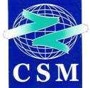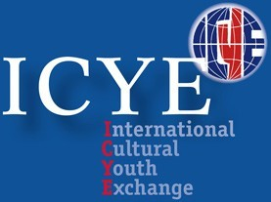

NATIONAL PROFILE. MOROCCO, 2020– 2021

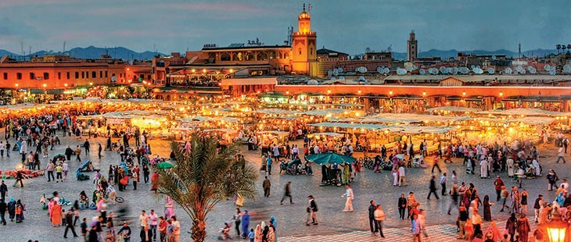

Chantiers Sociaux Marocains
RP. : 456 Rabat RP. Maroc Tél. / Fax : (212) 537 732266 E­mail : csm_morocco@yahoo.fr

The Kingdom of Morocco
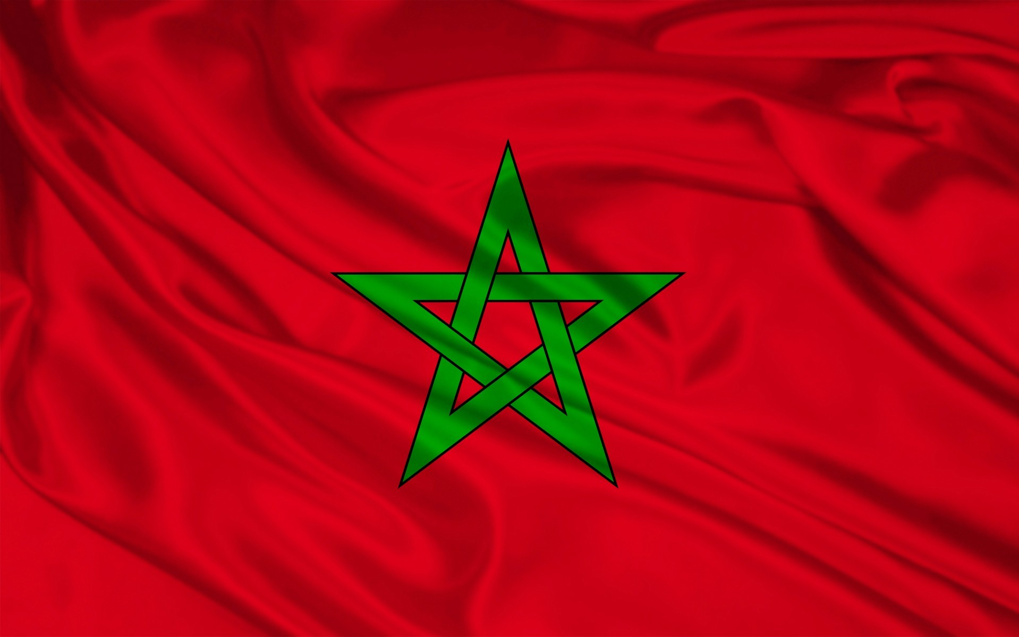

The Kingdom of Morocco is located in the northwest tip of the African continent. It is bordered both by the Mediterranean Sea to the north and the Atlantic Ocean to the west. The length of its coastline is 3,500 km, land borders are limited to the east by Algeria and to the south by Mauritania.

Official name: Al Mamlaka to Magribiyya (Morocco)
Area: 446,550 sq km. (712 550 square kilometers if you include the Western Sahara). Population: 32.187 million inhabitants. (Estimation 2011 Plan, the Government of Morocco) Capital: Rabat
Other cities: Casablanca, Fez, Marrakech, Salé, Tangier, Meknes, Agadir, Tetouan. Language: Arabic and Amazigh (official), French and Spanish
Religion: Muslim 99.4%, Christian 0.4%, Jewish 0.1% and 0.1% other religions. Currency: Moroccan dirham (DH). (1 € = 11.11 DH)
Form of government: democratic, parliamentary and social constitutional monarchy.

Social indicators
Population density (2011): 71.42 km2 hab.por P.I.B. per capita (2011): US $ 2,945
P.I.B. per capita (USD PPP) (2010): 4,560
GINI coefficient (2007): 40.9 Life expectancy (2010): 72 years. Population growth (2010-2020 est.): 1%
HDI (Human Development Index, 2011): 0.582 / (130th). Birth rate (2010): 20 and / or
Total fertility rate (2010): 2.3 children / woman.

Morocco has 32,272,980 inhabitants (16.4612 million are women and 15,811,780 are men) as published by the UNDP in 2011. The 58.8% of the population is concentrated in urban areas, especially large cities such as Rabat, Casablanca and Tangier. As a result of the difficult living conditions in rural areas in recent years is occurring in Morocco a major rural exodus to the big cities and it is estimated that in 2015, 64.8% of the country's population will reside in the urban environment.
According to the UNDP in 2011, Morocco is a country with a Human Development Index (HDI) medium (0.582), which places it in the set position 130 of 187 countries classified by the UNDP this year. This index has been criticized for not taking into account among its variables inequality in access to resources among the population. For this reason, since 2010 the UNDP additionally publishes the Human Development Index adjusted for inequality. According to this new index, Morocco has a inequality adjusted HDI 0.409. This difference of nearly two dozen notes the existence of large inequalities in access to resources and basic services and among the inhabitants of the country.
In the Maghreb, Morocco has the worst indicators in terms of * HDI how inequality-adjusted HDI ranking just behind Mauritania. Also it has the lowest per capita GDP of the entire Maghreb, again second only to Mauritania.
The Moroccan population has a life expectancy of 72.2 years. It is a young population, nearly 10% of the population is in the age group between 15 and 19 years. It has a population growth rate of
10.8 per thousand, with the national birth rate of 20 per thousand and the fertility rate of 2.4 children / woman to data released by the UNFPA * (Fundes of Nations UN Population). It has a rate of 65% active population (population over 15 years of working age) and a labor market unable to absorb the strong demand for labor. Official figures put unemployment in Morocco around 10% however, the unemployment rate among young women is much higher, standing at 19.4% and 23% respectively according to the World Bank. On the other hand, job insecurity is a constant work Moroccan market, being vulnerable employment rate 47% for men and 65% for women according to the latest available data for 2009. It should be noted that the rate of female participation is still three times lower than men (25.8% vs. 75.3%).
The Guaranteed Minimum Wage (SGMI) is 11.70 dirhams time (less than a euro). Per capita income is $ 4,081 (the equivalent of 3,060 euros) and the country's economic growth stands in recent years at around 4%. It is expected that the trend will continue even increasing in some tens and inflation to remain stable at around 2%. In contrast to these seemingly stable macroeconomic data, found in the country other inequality rates so that 10% of the population with fewer resources, has only 2.6% of the country's wealth. More than 800,000 people (2.5%) live on less than two dollars a day. However, if we consider the last poverty index developed and published by UNDP,

Multidimensional Poverty Index, the percentage rises to 10.6% of the population, which means more than 3.3 million people living in poverty. Youth, women and the Amazigh minority, are the groups that are most vulnerable in the country.

National public holidays
January 1: New Year’s Day
January 11: independence manifesto May 1: May Day
May 23: National day
July 30: throne day. The most important national holiday in Morocco – enthusiastically celebrated throughout the entire kingdom with fireworks, singing, dances and parades August 14: allegiance of Wad Eddahab
August 17: Youth feast
August 20: anniversary of the king and people’s revolution November 6: anniversary of the green March
November 18: Independence Day

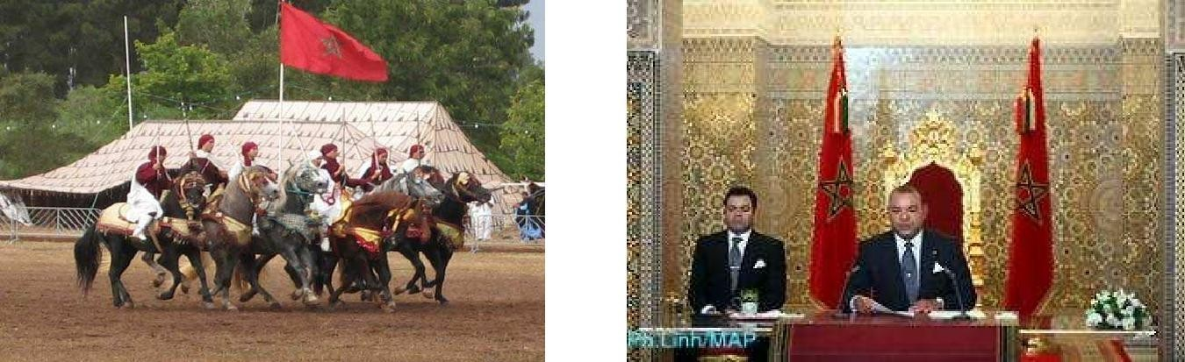
Currency:

Currency:
The Moroccan currency is the Dirhams (DH) divided into 100 centimes. There are 10, 20, 50, 100 and 200 DH notes. 1 and 5 dh coins and 5,10,20 and 50 centimes coins . One dirham is normally around 11 euro cents. The best place to change the money is at a bank or approved change office (indicated by a golden sign) .No commission is charged. You can withraw money in banks with a credit card and a cheque book, or directly from a cash dispenser in some large towns credit card are generally accepted in major hotels, shops and restaurants , and sometimes even in the souks !
In relation to the cost of living, you can have a coffee in a cafeteria for around 12-15 Dirhams, which means around 1.20 euro. One kg of apples can cost you around 6DH, 0.6 euro and a kg of chicken around 22DH, 2 euro.

Culture
Morocco is an African country with a very young population, most of its inhabitants, about 70% are under 30 years. It is a total of 26 million people. It has many traditional customs that in other parts of the world can be very curious. For example if a western tourist like to use light clothes you will have to make an exception when it comes to Morocco and much more if you try to enter a mosque. Morocco is a country full of traditions and customs due to the cultural influence of, African, Arab and Mediterranean. One of the most ingrained habits is the consumption of tea. Full-time infusion that is taken and it is common to share the drink with guests, hosts and even visitors to stores. It is a sign of hospitality but, by the high temperatures found in some parts of the country, is also done to avoid dehydration. With respect to the hospitality shown by sharing tea even with strangers, note that both in Morocco and in the Arab world a guest will always be welcome, even if it comes from a person who is hardly known, occasionally also invited to eat. In greeting the Moroccans are more formal in social situations than most Westerners. In the greeting often ask for the health and welfare of all family members. Always salute with the right hand as the left is traditionally considered impure. Kissing on cheeks is a practice among members of the same sex, whereas mean and women normally shake hands if they are meeting for the first time.

The food
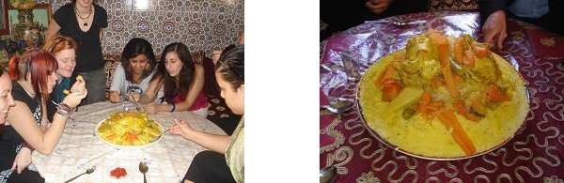
Moroccan cuisine offers refined preparations of sun-drenched fruit and vegetables, rare and aromatic spices, delicate fish and succulent meats. This is the very best of oriental cuisine, famous throughout the world- a real delight for your taste buds. Here are the Main Moroccan dishes wish you can must try

Couscous: the traditional family dish for Friday lunch, but you will find it every in the restaurants. You can taste many different types of couscous during your visit, for they vary according to the region and the cook’s imagination
Méchoui: oven or spit roasted lamb .the meat melts in your mouth!
Pastilla: A fine flaky pastry stuffed with chicken and almonds : the famous Moroccan sweet and salty taste there are also variants with fish , chicken and even with milk for desert.
Tajine: this word designates both the decorated earthenware plate with its distinctive conical cover and the dish itself (Meat, chicken or fish stew with vegetablesaste it and you will understand why Tajine is the moroccan national dish.
Mint tea: refreshing, warming and stimulating drunk in the morning, after meals or any time. A pleasure you should never refuse.

Religion
The vast majority of the Moroccan population are Muslims, the Sunni line, which means living religion in a quite deep and orthodox way. Some variety in religious practice is given in rural areas beliefs linked to local saints.
For Muslims the concept of life is based on some values based on the Koran: the word of God and the traditions of the Prophet. Its five pillars are: the act of conversion or profession of faith (chahada); prayer five times a day (salat), almsgiving to the poor (zakat); fasting in Ramadan and the pilgrimage to Mecca.

Religious holidays
- Ashura: the first month of the Muslim calendar. It is celebrated with couscous and tail lamb, last memory of the feast of sacrifice, and in the morning a varied breakfast of Lgros = bun butter with sesame seeds, L-kaak = small crowns based celebrated flour, grains of fennel and sesame and nuts (walnuts, raisins, almonds, dates, dried figs). Even for children is a special day, they go to the streets in groups playing drums, throwing firecrackers.
- L-mulud:
Is the feast commemorating the birth of the Prophet Mohammed (Muhammad). In some regions there is a free choice of dishes to prepare.
- Ramadan:
It is the month of fasting, it is for the Muslim the chance to assert their ability to freely give up all earthly vanities for thirty days. From sunrise to sunset, Muslims must give up all kinds of food, drink and carnal pleasures.
Islam besides being a religion is also a culture and a code of life. Moreover, the king of Morocco,

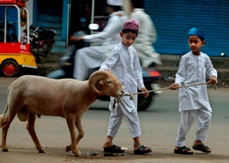
which claims to be a descent from the Prophet Mohammad, has the honorary title of Amir al- Mumineen, commander of the faithful, and therefore responsible for ensuring respect for Islam in the kingdom. The way Muslim government is a monarchy with an only constitutional provision that can not be revised.
Ilustración 1: Eid Al-Adha

Women in Islam
The complex relationships of women in Islam are defined by Islamic texts and the history and culture of the Islamic world. Although the Koran states that men and women are equal, he also says that "Men are the protectors of women”. Although the Koran is expressed in these terms, the superiority of men is interpreted in terms of the strength of context- men keep women. This refers to the relationship between husband and wife, not in the general context of society. Sharia Islamic jurisprudence speaks of complementarity, differences exist between the roles of women and men, rights and obligations. However, the Koran does not mention that women should be housewives. In most Muslim countries, women have a different set of rights as to marriage, divorce, civil rights, legal status, dress codes and education based on different interpretations. Analysts disagree as to whether the correct interpretation of these religious imperatives and whether they are fair or not.
Hijab or headscarf. The Koran indicates that women be covered to distinguish people, to be identified as a respectable, committed and devout Muslim, to protect eyes and malicious and annoying insolence of some men, and their comments and unwholesome intentions. This will be respected and valued by society. Beyond that, of course, is the interpretation that society can give. In Morocco, for example, women are not required to be covered, but if it is true that sometimes are influenced by their families or husbands to wear the veil as a symbol of respect.

The question of gender
The Gender Inequality Index by UNDP Morocco in 2011 is 0,510 to 1. Moroccan women still suffered from serious discrimination in relation to men and their participation in society continues to be relegated to the private sphere as evidenced by its low rate of participation in economic activity (25, 8% to 75.3% of men). In addition, unemployment affects more strongly (19.4% against 9.8% of men) and job insecurity (65% female precarious work to 47% of men). Wage differentials are also a constant labor market so that women are paid 4 times less than men for doing the same job. It should be noted the high rate of violence against women. According to the latest survey "Prevalence of violence against women in Morocco" made in 2009 by the Haut Commissariat of Morocco on a sample of 8,300 women aged between 18 and 63 years, 62.8 % they had been victims of some form of violence in the last 12 months. In 55% of cases, this violence is exercised in the marital sphere. Rates of violence against women are twice as high in urban areas than in rural areas.

With the aim of enhancing the role of Moroccan women in society, in 2004 the Moroccan government reformed the Family Code (Moudawana) in which women's rights are recognized. Despite this, the Committee on Economic, Social and Cultural Rights Rights has expressed concern about the prevalence of discriminatory issues in Moroccan law, especially concerning the right to inheritance and criminal matters and serious disregard in the fight against gender violence. During the last decade, equality of women had been a subject of ongoing debate in Morocco. The Committee on the Elimination of All Forms of Discrimination against Women had warned about the need to undertake deep reforms on gender equality, with measures for the equalization between women and men and compliance objectives the main international treaties, particularly the Convention on the Elimination of All Forms of Discrimination against Women and its Optional Protocol, the Declaration and Platform for Action and the outcome of the twenty-third special session of the General Assembly entitled "Women 2000: gender equality, development and peace for the twenty-first century". The directives of King Mohammed VI in regard to the promotion of women translate the political will to make gender equity, while the purpose and a factor of economic and social growth. The new constitution provides that women enjoy, on an equal footing with men, of all freedoms, political, economic, social and environmental civil rights.

While these reforms have had an impact on the whole society, in reality, its implementation is uneven, particularly in rural areas where educational communities in the targeted school enrollment is around 96% for boys and 88% for girls. In schools, the dropout rate is 6% and only 1% are girls, and 10% repeat with 2.7% for girls. The main causes are early marriage and the distance to school.

Despite these figures, the educational performance is usually better in girls than in boys. A level of faculty women are always being a minority, low access by women to senior cycle studies, coupled with the problems of reconciling work and family life. The lack of women on the progress made legislatively in favor of equity in Morocco usually generally very low.

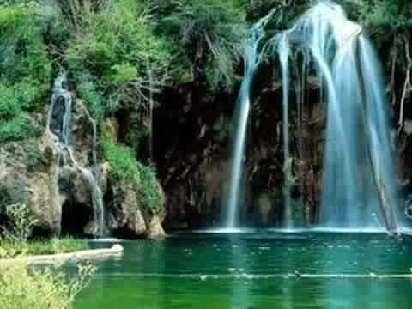

Environment
One of the characteristic features of our age is the environmental concern and Morocco has not been an exception, although it is true that environmental conditions in the country are not the best, in recent years, it seems to have become aware of their importance and are numerous the initiatives are underway in this regard. In 2002, after a study of the environmental situation analysis (MEER) causes deterioration in Morocco are identified. And in urban areas, the high rate of emissions, lack of effective management systems and waste water contamination is found. In rural areas, this situation is comparable due to the mismanagement of natural resources and the limited intended capital. To all this must be added the urban population growth experienced by aggravated by the phenomenon of rural exodus which further complicated the situation country. Meanwhile rural conditions were not very hopeful because the mismanagement of natural resources decreased capital for this purpose joined, thus enhancing the exodus to the city. After these results Morocco launched a national plan of action for environment (PANE) focused on four areas: management and water protection, treatment and reduction of waste, reduction of air pollution, improving air quality and protecting soil and the coast. Activating plans such as national water strategy 2009-2030 sector; national program of household waste management and decontamination industrial background. With regard to water treatment, the national office of l'eau potable (ONEP) has designed more than a hundred performances based on three pillars: strengthening infrastructure, creating access to safe drinking water (especially in rural areas) and treatment and water sanitation.

Significant progress in terms of mobilization of resources for the water sector has been marked allowing developing multiple subsectors (irrigation water, sanitation hydropower) and alleviate the risk of flooding. In addition due to weather a new water policy changes it is necessary to define the sectoral priorities. Why it has adopted a new national strategy in the sector for the period 2009- 2030, setting as priorities: saving water, improving access to drinking water and demand management focused on quality of resources. As for waste management, the government has launched a national program of household waste management (PNGDMA) with a large budget that aims to turn around the situation in the next 15 years. With regard to industrial wastes has created a fund for industrial decontamination (FODEP) will create facilities dedicated to the treatment and disposal of industrial waste. The air pollution control aims performed by boosting renewable energy, already discussed in the section on energy. In education there are different levels of environmental management. In schools is a common problem that the presence of prefabricated classrooms and asbestos roofs occurs. The poor state of these structures and the presence of cracks aggravates the situation by allowing release of asbestos dispersed in the air and can cause diseases such as asbestosis, lung cancer and serious respiratory deficiencies pleura. There is also a low hygienic health coverage, since many schools do not have latrines or are damaged.

Cultural Diversity
Morocco is a country of multi-ethnic groups with a rich culture and civilization. Throughout its history, he has received visitors have impacted on the social structure of Morocco. It is also a country in which there are different types of religions such as paganism, Judaism, Christianity and Islam (the latter being the majority). 70% of Moroccans are of Arab ethnicity and 30% are ethnic Berbers, and at least one third of the population speaks Berber language (Amazigh). A major in the field of recognition and promotion of cultural diversity has given Morocco was the Constitution adopted in 2011, which recognizes the Amazigh as official language along with Arabic, and at the same time provides for the adoption and development of breakthrough linguistic and cultural policies to ensure their protection, as is creating a National Council for Languages and Culture Moroccan. Despite these advances in the field of standards, the implementation is not a priority for the state and not be seen firm steps towards real and effective integration of the second official language.

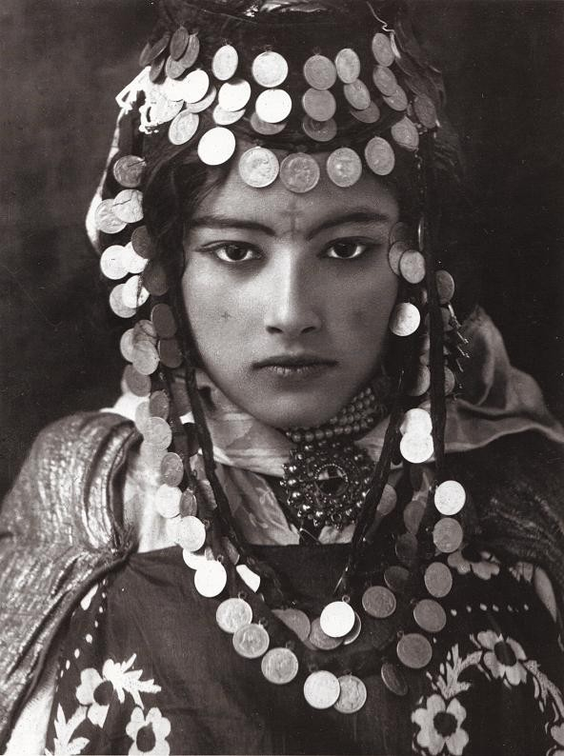
Ilustración 2: Bereber woman

Morocco is considered an Arab-Berber country, although some people consider it a largely Berber- African identity. Approximately 42% of the population have a Berber identity, although more have Berber ancestors. These are mainly identified by language, by their traditional dress and its culture, and its distinctive music and dance. The Berbers do not identify themselves by blood. Your language has not yet been officially recognized in Morocco, although the French, for example, considering official language because it was the colonial language. Classical Arabic remains the primary official language of Morocco and is typically used in cultural and socio-economic activities, in addition to print media, but never used among Moroccans. Linguistically, Berber belongs to the Afro-Asian group and has many accents and variations. The Tachelhit (also known as "Soussia") is spoken in the southwest of the country, in the area surrounded by Sidi Ifni in the south, Agadir and Marrakech in the north in the Draa / Sous eastern valleys. The Tamazight is spoken in the Middle Atlas, between Taza, Khemisset, Azilal and Errachidia.
Finally, the Tarifit is used in the area of Rif, in northern Morocco, in cities such as Nador, Al Hoceima, Ajdir, Taourirt or Taza.

Education
Public spending on education is 5.6% of GDP. The median rate of literacy among the adult population over 15 years is 56.1%, although differences between urban and rural areas (71.2% and 43.3% respectively) were observed. The literacy rate is increased among young people between 15 and 24 years (79%) although differences are presented by sex, with the literacy rate for young women 72% and men 87%. This rate is drastically reduced from the older population, more than 50 years, to 28.2%. Attendance rates at elementary school are considerably higher in children / are (91% of boys and 87% girls). The dropout rate stood at 4.1% for primary education, but rises to 13% in secondary education. According to the UNDP, the average number of years of education in the country is 4.4 years, although the average number of expected years of education among younger generations, it is 10.3 years.

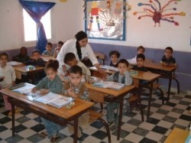

Immigration
"Migration" remains one of the most controversial issues and may even be one of the major challenges of the century, marked by new geopolitical challenges, both regional and global. Migration is becoming increasingly important in social, economic, political and cultural changes of our planet "Earth". It is one of the essential components in the logic of increased exchanges involving globalization.
Since the implementation of the Schengen Agreement in 1990 and the pressure of the European Union on the Maghreb, EU countries are putting more efforts to discourage, deter and control clandestine flows. The result has been the closure of the borders of Europe, the tightening of controls that lead to many prospective migrants to seek alternative solutions already manage to develop strategies that circumvent the laws and borders. Due to its particular geographical position, the central Maghreb is increasingly required to actively play the role of "bounce space, military glacis" at the gates of Europe, as Mexico and the United States stuck situation. Clandestine migration represent a challenge for central Maghreb countries (Algeria, Tunisia and Morocco), to Spain and / or Italy.

Morocco is today confronted with immigration transit, temporary or long-term. Due to an impasse as a 'trap effect "Morocco has become a country of immigration-residence default rather than transit to many foreigners. Compared with Moroccans abroad, the number of immigrants and foreign residents in Morocco remains low, amounting to some 78,000 individuals in a regular situation. It would, according to Interior Ministry estimates, between 25,000 and 40,000 migrants in situation called "irregular". However, the Moroccan government has to carry out a radical change in the management of this dossier, including the legal framework, in order to integrate this new trend with legislation that now take into account the need to protect rights of migrant workers entering the country, who are passing through or taking up residence.
Morocco is revolutionizing its immigration policy, while trying to consolidate its African political entrenchment, strengthen their Euro-Mediterranean presence, but also position itself as a country that respects the rights of migrants. Also it intends to implement a new policy on asylum and immigration, guaranteeing the rights of migrants and refugees, based on a participatory and inclusive approach of all parties.

Health
Public spending on health is 1.7% of GDP, still the country that invests less in health across the Maghreb.
The Moroccan health system has undergone a series of social and financial problems due to a demographic and epidemiological transition, on the one hand, and lack of funding on the other. Thus, the state budget covered only 41% of public health spending, and only 5 million Moroccans benefit from healthcare.
Moroccan Health System sectors
In Morocco, the organization of the health care system is based primarily on two sectors:
The public sector, represented mainly by the Ministry of Health and Sanitation of the Royal Armed Forces.
The private sector (profit and nonprofit), characterized by the multiplicity of stakeholders, both in the production of care and prevention, management and financing.

The political framework
Form of government: Kingdom, constitutional monarchy with an elected parliament. Executive power: Executive power is shared by the government and the king. Prime Minister acquires the status of head of government and presides over this title the Governing Council, but the Council of Ministers is still chaired by the king. The Governing Council is composed of all ministers, deputy ministers and other ministers of state. Deliberates on public and sectoral policies,

the commitment of government accountability to the House of Representatives, the current issues related to human rights and public order, draft laws, legal decrees, draft decrees. In addition, it is responsible for appointing the general secretaries and heads of central government, university presidents, deans and directors of schools and colleges.
The Governing Council has only one power of deliberation on general policy of the State, international conventions, the finance bill. The Council of Ministers, which concerns only the head of government and ministers, has the power of the strategic directions of the state policy, the revision of the Constitution, draft organic laws, the general lines of the draft finance law amnesty, draft texts on the military, the declaration of martial law, the declaration of war.
The legislature: Parliament consists of the House of Representatives (325 deputies elected by direct universal suffrage for five years) and the House of Councillors (270 members elected by indirect universal suffrage for 9 years).
Parliament votes the law; any project must be examined by both chambers. Also shares the initiative of the laws with the Prime Minister.

Indicator of press freedom: World Rank: 136/180
Evolution: same place compared to 2013
Source: Worldwide Press Freedom 2014, Reporters Without Borders Indicator of political freedom
Ranking: Partly Free Political Freedom: 5/7 Civil Liberties: 4/7

Territorial Division
With the reform of the Moroccan territorial administration in 1977, Morocco is divided into three levels:
- The 16 regions, whose position is a wali (Governor equivalent to charge) and a regional council. These regions have the status of local authorities. Three of them form part of the Western Sahara, a territory administered by Morocco, but the UN includes in its list of the United Nations autonomous territories.
- The regions are divided into 45 provinces and 27 prefectures (the urban equivalent of the first), which constitute the second layer of the housing management and are led by a governor.
- Each province or prefecture is subdivided into districts (cercles), municipalities, communes and in the case of metropolitan areas, in neighborhoods (arrondissments).

Finally, the wilaya is an administrative division established in 1981, which brings together provinces and prefectures. Therefore, they fall between the first (regions) and second (provinces) level. However, the term wilaya is often used as a synonym of region or province / prefecture. The new territorial division, advanced regionalization premise is finally approved a few days ago by the Council of Government. This new map will sign a decree Abdelilah Benkirane and Mohamed Assad, the interior minister. This division will be effective from this month, according to a government source. Morocco now have 12 regions, the larger the region of Tangier-Tetuan-Al Hoceima.
The Rif name disappeared from the administrative language, while complaints that Meknes, convertiese in the capital of the region have not been taken into account. Meknes was integrated in the region of Fez. In a report related to the new territorial division, the Advisory Board on regionalization (CCR) believes the new geographical configuration was created on the basis of compromise and pragmatic criteria, fleeing regionalist, ethnic or other sensitivities.

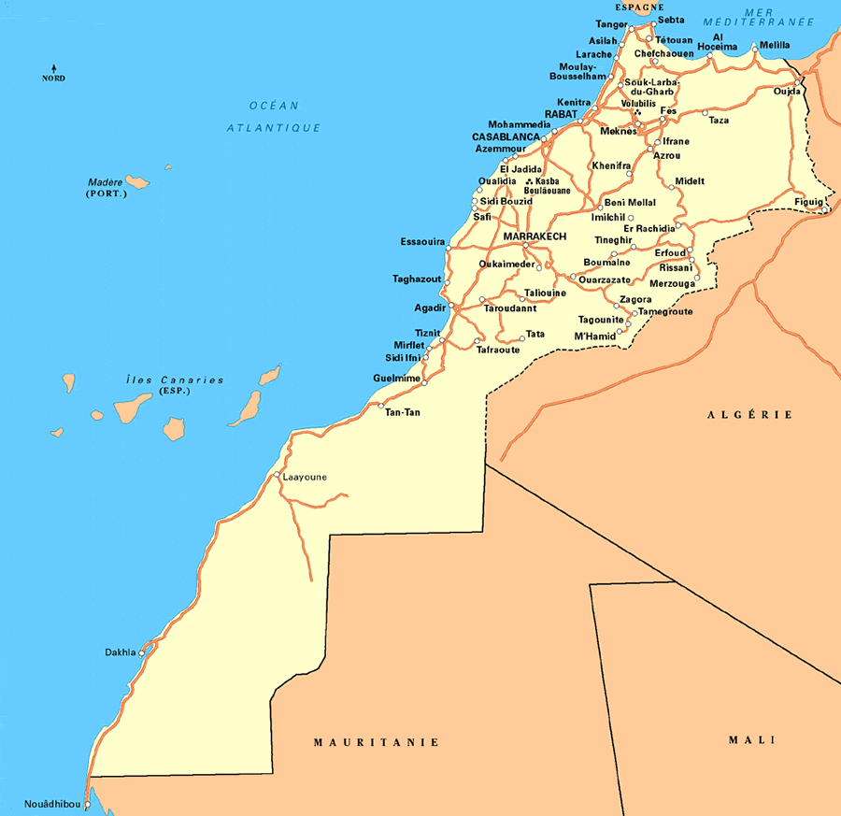

Means of transport

Railway: the railway system, with its 1,893 km of track is more concentrated in the north of the country .the express train is fast, comfortable and air-conditioned. Some major cities are not served by rail, but ONCF provide bus connection. The price is not very expensive. Rabat to Casablanca 93 km about 35 DH/ 3 euros. Rabat to Marrakech 334 km about 120 DH / 11 euro.

Buses
The most popular means of transport. they will take you everywhere at low rates. CTM LN, the Main Company, runs comfortable, air-conditioned coaches. Inside the cities they are buses wish take you between the neighborhoods the price is 5 DH / 0.50 euro .

Small and big Taxis:
Very cheap, the « petit taxi « (Maximum three people) have a distinctive, bright color for each town, red in Casablanca, blue in Rabat, etc. They only drive in town and will not, for example take you to the airport some way from the city center. They can take other passengers who are going to the same direction. Settle the price before leaving if they have no meter.
Collective or individual, the « grand taxi » (Maximum 6 people) will take you to outer suburbs or other towns you are advised to fix the price in advance.

Morocco Visa System
In general people can enter to Morocco, without getting a visa. This one is considered as touristic visa, this means that it covers tree months only.
Actually the volunteers, once they arrive there he/she can choose one of two options:

  - To ask for the the license residence for one year , the needed documents are :
1.1- Copy of passport
1.2- health certificate
1.3- A document received by the Ministry of Justice 1.4- The agreement you get from your organization
1.5- A document given by CSM 1.6- 06 Photos

  - To ask for the prolongation of the visa
This document has to be done too weeks before the visa finished 2.1-03 Photos
2.2-03 copies of the passport
2.3- Fill in tow document about your self 2.4- A document given by CSM

ICYE Morocco
Chantiers Sociaux Marocains has its main office in Rabat. The organization the ICYE Federation as associate member in 2001. Voluntary service placements are mainly in education, health and development projects working with children, women and the local community at large.
We are a network of 45 sections and we are part of:
- UMAC , Moroccan union of work camps association
- Associations space
- UMAV, Maghreb union of volunteering action
- ICYE, International Cultural youth exchange
- Alliance of workcamps associations
- Foundation Anna Lindh

Our general aim is to promote peace, tolerance, solidarity and self determination in Morocco. The main objectives of the organization are to contribute to the strengthening the civil society,developing human rights, democracy, peace and solidarity in Morocco. We work for the awareness of the importance of volunteering and the need to its recognition and reinforce the values of citizenship and strengthen the capacity of the population to contribute to sustainable development.
All our staff has a large experience organizing work camps and international events.
Large experience when organizing international events and coordinating practical arrangements. Good communication skills, able to speak English, French, Arabic and Spanish.

General Assembly
We held meetings every three months with all the members to continue or disapprove actions taken by the National Board, sets guidelines for further developments and decide on financial reports, budget and statutes.
All matters of national importance, such as the planning and coordination of activities, finances and publicity belong to the responsibilities of the national board. Its members are elected by the General

Assembly, to which they are responsible. All National Board members are volunteers working in a honorary capacity.

Every volunteer in Morocco has a mentor who is responsible for keeping up the contact with the volunteer and who can be approached in case of problems. The mentor reports their information back to the ICYE-office.

The Office
ICYE Morocco has its central office in Rabat, with two coordinators working on it on a permanent basis and several national volunteers. The office is responsible for:
Coordination and Organization of our programs Administrative matters
Steady development and expansion of the program offered in Morocco.

Very useful advices
Women should avoid provocative clothing (short pants or skirts and uncovered shoulders are considered provocative)
  - Don´t smoke, drink and eat in public during the day in the month of Ramadam
  - Never disturb someone in prayer
  - Avoid criticizing politics or religion!
  - Don´t touch any illegal drugs other cultural advices could be :
  - You should take of your shoes before entering a room with a carpet.
  - Don´t eat or greet people with your left hand as Moroccans use that hand for toilet
  - Never refuse if you are invited by locals to drink tea
  - It is a tradition and a pleasure to bargain on the price.

