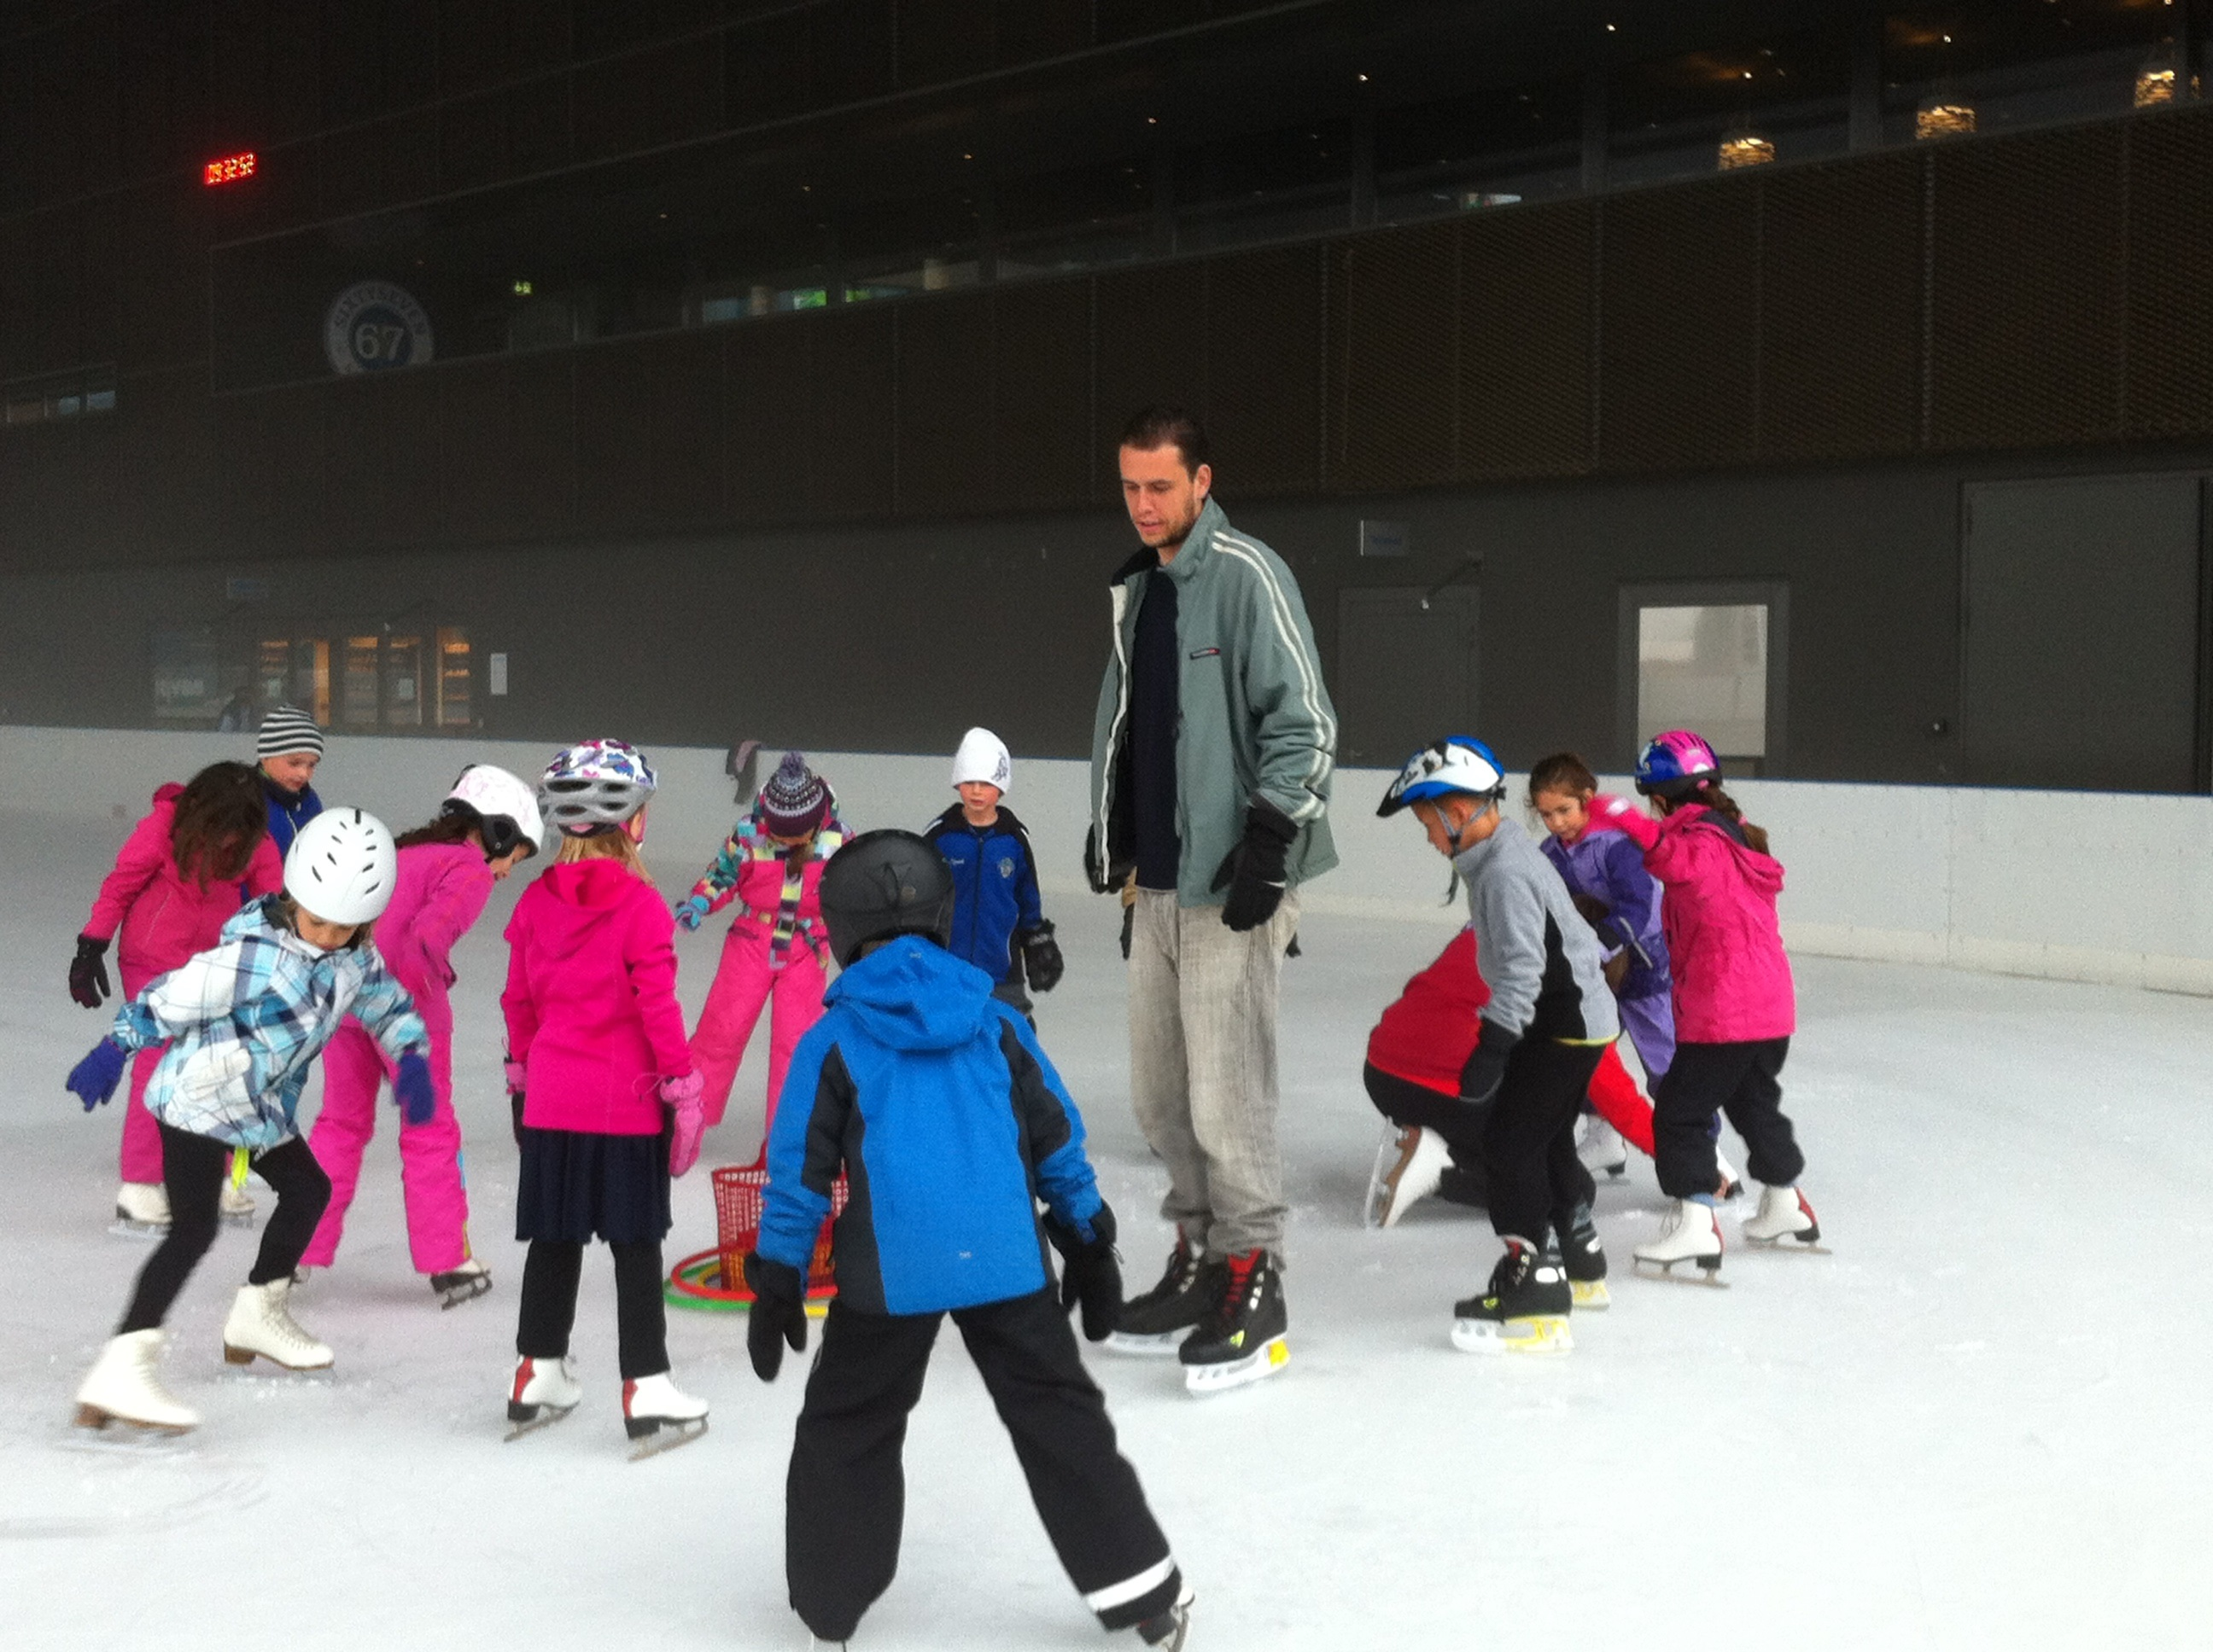
+

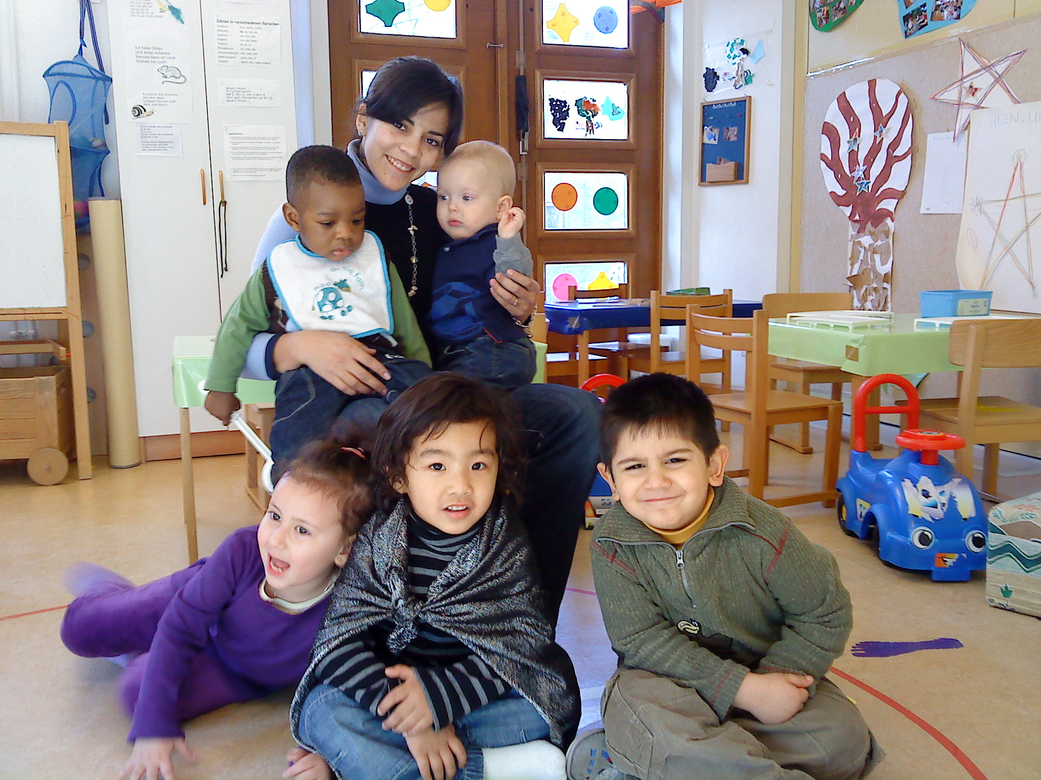

ICYE Switzerland
Work Profile 2019/2020

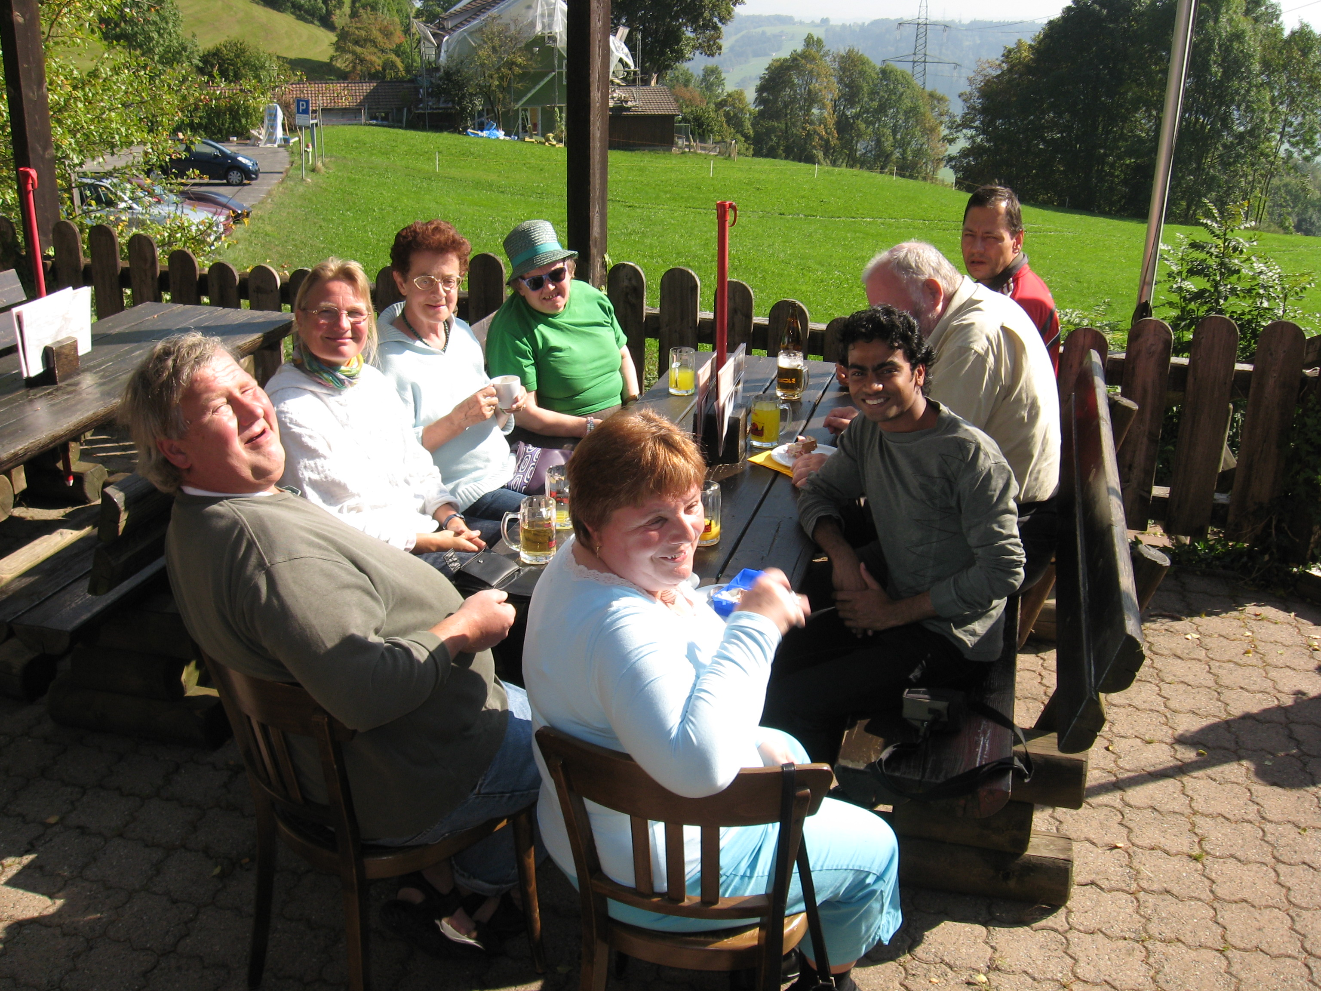

Dear volunteer,

Welcome to Switzerland! We are looking forward to meeting you soon!

In this document you find examples of placements available for the exchange year 2019/2020, but let us start with some important general information:

- In order to place you in a project, we need your Priority Project List, filled out as detailed as possible and signed: please tell us in which fields of work you would like to advocate for and why. You should also indicate in which 3 projects you would prefer to work. The Project Priority List is attached to our National Profile.

- We send your Project Priority List with your Candidate’s Application Form, Motivation Letter, picture and possibly your Curriculum Vitae to the projects that you indicated as favourites. By this, projects usually have 2-3 volunteers to choose from: they will select the volunteer, of whom they think fits best in the project. You are welcome to add a detailed motivation letter and CV for your employer! It is very important to make a realistic, detailed and open-minded impression with the above-mentioned documents.

- ICYE Switzerland will try to place you in one of your favourite projects. If that is not possible, we will find you a project that is similar and your interest of fields of work. We will be in touch with you and discuss the possibilities with you. Any additional information about yourself and your interests helps us to find a good match for you!

- We would like to remind you that you work in the project for the entire exchange year. Due to work permit/visa law, a change of project is not possible in Switzerland.

- Most projects are in the field of working with disabled people, children and community centres. In Switzerland, these are the main fields where volunteers are needed and where it is not an issue when you do not speak a lot of German in the beginning.

- We offer only very few residential projects, in which we prefer to place volunteers older than 25. Therefore we ask you to be willing to live in a host family. More detailed information about host families in Switzerland is in our National Profile.

- Please be aware that the duties of a volunteer include cleaning and tidying up in almost every project (for both men and women!).

- In most projects the acquirement of at least a basic knowledge of Standard German is very important. We expect you to be willing to learn as much German as possible: the more you improve your language skills, the more responsibility and variety in your daily work you will get. It is an advantage – and we highly recommend - starting learning the language already in your home country!

- Generally, the volunteer has an 80% job. This means that you will work about 32 hours during 4 – 5 days per week (working hours can vary in the different projects). So you will spend a considerable time of your exchange year working! Even as a Volunteer you will have a considerable amount of work to do and are required to take your work serious.

- In some projects the volunteers have to work during weekends or evenings from time to time. They will have free time during the week as compensation.

Please note that the work profile presents only a selection of projects. We ask you to state the field you are interested to work in and we will try to find a project that suits you.

In case of questions please contact Felicia Solothurnmann (program manager Incoming), ICYE Switzerland (incoming@icye.ch).

We are looking forward to meeting you!

ICYE Switzerland

Content

1. Work with young children 5
2. Work with school children 8
3. Work with disabled adults 9
4. All-rounder in social or cultural organisations 11
Work with young children

Name of the project | K5 Kinderhort – für Kinder aus 5 Kontinenten  www.k5kurszentrum.ch/home
Project Code | 1.1
Country | Switzerland
Location (city, town) | Basel
Areas of Project | Integration/children day care
Aims | The K5 is a cultural centre for people from all five continents. The aim is to support directly the process of integration and the equality of opportunities in the region.
Activities | The main activities are German courses and projects for immigrants in the area of language as well as professional and social integration. In order to enable the people to participate in the courses the K5 has a day care centre for children in the age of 6 months to 5 years. The day care centre aims to create a warm and calm atmosphere that makes children feel comfortable, builds up trust and enables each child to develop. The children do activities like drawing and painting, looking at children’s books, hearing to stories etc. The staff pays special attention to language development in German. The day care centre is based in the Gundeldingen Quartier. With 3 different day care centres the K5 Kinderhort is able to take a maximum of around 100 children each day in 4-6 different groups.
Community Context | Basel is the third-biggest city of Switzerland and lies at the border to Germany and France.
Volunteer requirements | Male or female, age 18 – 30. The volunteer must have a liking and ability to deal and work with children from different backgrounds and regions. He/she must be patient, open-minded, social, flexible, creative and willing to learn the German language quickly. (The language in the daytime nursery is dialect and standard German.)
Volunteer tasks | - Supporting the day care team  - Reception of the children  - Helping the children with changing clothes and occasionally change diapers  - To participate in collective and individual play/games, for example singing, drawing and in- and outdoor activities  - Tidy up and cleaning  - There is also a bit of administrative work to do; like copying and filling in files and documents, control of lists and making shipping notice.  The volunteer’s personal creativity can help in making his/her job more enjoyable.
Hosting situation | Host family
Lunch is provided by the project | No (the volunteer has to bring his own but can heat it in the kitchen)
Number of volunteers | 1

Name and address of the project | KITA LIFE  www.kita-life.ch
Project code | 1.4
Location (city, town) | CH-8700 Küsnacht
Areas of project | Children (From 3 month to 6 years)
Aims | The KITA LIFE is a day-care for children. At the moment they care for 12 children in the age between 3 months and 4 years. They use the pedagogy of Montessori as their guidelines and offer a bilingual day-care (German-English). One day a week they spend in the nearby forest. On the other days the children play on the different playgrounds in the area, in the garden or can develop their creativity in the artists workshop.  More information: http://www.kita-life.ch/
Community Context | Küsnacht is a small city with 13’283 inhabitants at the lake of Zurich. The next biggest town is Zurich. It only takes 15min by train to get there.
Volunteer requirements | The volunteer should enjoy working with children. The person should be open, motivated and flexible. He will be part of the team and should take his work serious and be punctual and a reliable co-worker.
Volunteer tasks | The volunteer has the chance to work in all parts of the KITA. Most important will be to assist the caregivers in taking care of the children. This includes to bring in own ideas for activities for the kids and assist in the organisation and implementation of the daily program. The volunteer will have the chance to learn more about the pedagogy of Montessori and can assist in the different team meetings and couching in order to learn as much as possible about the work in a day-care. Next to the work with the kids the volunteer will do different household tasks such as cleaning or cooking.
Hosting situation | Host family
Lunch is provided by the project | Yes (including breakfast, lunch and snack)
Number of volunteers | 2

Name of the project | Kinderkrippe Lenzi  www.kita-lenzburg.ch
Project Code | 1.3
Country | Switzerland
Location (city, town) | Lenzburg
Areas of Project | Day-care centre for children
Aims | The Kinderkrippe Lenzi provides a place for children to stay and play while the parents are working. The Day-care offers places in four different Daycare centres.
Activities | The Kinderkrippe Lenzi takes care of children in the age from 3 months till 6-7 years. They have a structured programme with different activities for the children, e.g. different games, singing, doing handicrafts, painting, playing theatre, listening to stories, cooking and baking. They also spend a lot of time outside, so the children learn about nature.
Community Context | Lenzburg is a town in the central region of the Swiss canton Aargau and it is the capital of the district of the same name
Volunteer requirements | Interested and skilled in working with children. Reliable and punctual.
Volunteer tasks | The volunteer tasks are the following:  o Child care  o Play with the children  o Help with the household  o Assist in the central kitchen where the lunch for 5 different day-care centres is prepared.
Hosting situation | Host family
Lunch is provided by the project
Number of volunteers | 2

Work with schoolchildren

Name of the Project | Schule Uznach  www.schule-uznach.ch/de/schule/fotoalbum/
Project Code | 2.3
Location (city, town) | Uznach, Canton St. Gallen
Areas of Project | Education, Pedagogy, Youth Work
Aims | Insight into working at a public school (With children and teenagers aged 4 – 16)
Activities
Community Context | School Uznach:  - Kindergarten through High school with around 750 students  - around 150 employees (100 of which are teachers)  - Music school  - Providing midday meals with caretakers  - Youth work for the municipality Uznach
Volunteer requirements | - Interested in working with children and teenagers (education & caretaking)  - Open, joyful, patient and happy to help  - Prior pedagogical education or experience with children or teenagers is helpful, but not required.  - IT and computing knowledge is helpful  - ideally at least 25 years old
Volunteer tasks | - Accompanying small children on their way to school.  - Assisting individual students complementary to the normal classes (private tutoring).  - Supporting teachers during classes.  - Accompanying classes for events like school excursions and school camps.  - Potentially support individual teachers and school administration with the development of IT-tools and/or help with IT/computing related projects.  - Help taking care of students at the midday meal the school provides and participating in youth work of the municipality Uznach.
Hosting situation | Host family
Lunch is provided by the project | Yes
Number of volunteers | 1

Work with disabled adults

Name of the project | Brühlgut Stiftung  www.brühlgut.ch
Project Code | 4.1
Country | Switzerland
Location (city, town) | Winterthur
Areas of Project | Disabled adults and people with physical impairments
Aims | The Volunteer will be engaged in the industrial Production. He / she assembles different customer orders together with our clients.  He/she works with disabled people and contributing to sustainability and development.
Activities | The Volunteer will be engaged in the industrial Production. He / she assembles different customer orders together with our clients.  He/she works with disabled people and contributing to sustainability and development.
Community Context | Winterthur is a city with approximately 100’000 habitants. Winterthur is the 6th biggest city of Switzerland. Winterthur is close to Zürich.
Volunteer requirements | The volunteer should be:  - open to work with disabled people  - interested in a new working area  - willing to take responsibility
Volunteer tasks | Collaboration in planning and accomplishment of different tasks  - Support of the disabled people at the workplace.  - Facilitation of the group process (participation, support, aid)  - Work together with family members of the disabled people and with internal/external specialist departments  - Administrative work  - Work in different projects of the Brühlgut Stiftung  - Willing to learn German  The volunteer will participate in a workgroup during the whole year.  If the Volunteer is interested, it’s possible that he can work at different Departments of the Brühlgut Stiftung
Hosting situation | Host family
Lunch is provided by the project | No (volunteer has to bring his own lunch)
Number of volunteers | 1-2

Name of the project | Stiftung Roth-Haus  https://rothhaus.ch/
Project Code | 4.2
Country | Switzerland
Location (city, town) | Muri
Areas of Project | Physically and mentally disabled adults.
Aims | The aim is to enable the disabled people to develop their resources and abilities. The work with the disabled people is focused on aims like independence, mobility, responsibility and communication abilities.
Activities | There is a home and a workplace for the disabled people. The home is divided into four groups. A team of 6-10 co-workers attends each group. In total around 30 disabled people live in the home. The age of the residents ranges from 18 to 70 years. In the workplace there are two groups and 24 people in total.
Community Context | Muri is a small village in the canton of Aargau, between Zurich and Lucerne.
Volunteer requirements | The volunteer likes to work with physically and mentally disabled people. The work requires reliable volunteers who have a positive attitude and are able to work in a team.
Volunteer tasks | The volunteer tasks are:  Support of the disabled people in their free time and on their working place (for example: making the shopping together, accompany them on excursions)  Collect experience in the area of pedagogical, custodial and organizational work.  Work with the Roth-Haus team.  Get to know the culture, the structure and the quality assurance processes in a residential home.  It’s a hard physical and mental job, but it can be very rewarding! Besides, the team is very supportive.
Hosting situation | Host family
Lunch is provided by the family | yes
Number of volunteers | 1

All-rounder in social or cultural organisations

Name of the project | Schweizerische Jugendherbergen SJH  www.youthhostel.ch/de/hostels/luzern
Project Code | 6.1
Country | Switzerland
Location (city, town) | Lucerne
Areas of Project | Tourism, youth
Aims | The aim is to provide a possibility for people from all over the world to get in touch with each other. The youth hostel association focuses on social and ecological tourism with high quality for young people and families.
Activities | Jugendherbergen SJH is the Swiss youth hostel association. They provide accommodation in all regions of Switzerland for a fair price.
Community Context | There are youth hostels in all bigger cities as well as in touristic mountain areas.
Volunteer requirements | The volunteer has to be interested in meeting people from all over the world, he/she should be open and not shy to talk to people even if there is a language barrier, he should be open-minded and not afraid of new tasks.
Volunteer tasks | The volunteers works in different departments:  - Kitchen: assist in preparing warm meals + desserts, help with breakfast buffet, do the dishes, cleaning the kitchen  - Housekeeping: help with cleaning the rooms and guest areas in the hostel, help with the laundry. different works around the hostel  - Reception: work at the reception, handle guests demands (working at the reception is only possible with good language knowledge)
Hosting situation | Residential project. (People working in the youth hostel can sleep in every other Swiss youth hostel for free when they are travelling.).
Lunch is provided by the project | All meals (breakfast, lunch, dinner) are provided in house.
Number of volunteers | 1-2

Name and address of the project | FAZ – Familienzentrum Gundeli  www.quartiertreffpunktebasel.ch/quartier-treffpunkte-basel/faz-familienzentrum-gundeli/
Project Code | 6.2
Location (city, town) | Basel
Areas of Project | Meeting point for families with children
Aims | Providing a meeting point for young families, support them in daily life with different offers and activities.
Activities | The centre offers an open meeting point with a café and organises activities for families, such as advice for parents, baby group, singing together, doing handicraft work and many other things. The FAZ is based on volunteer work, there is almost no paid staff.
Community Context | Basel is one of the bigger cities in Switzerland.
Volunteer requirements | The volunteer should be open and interested in the different activities of the FAZ.
Volunteer tasks | The volunteer tasks are:  - Support during the open meeting point (helping with the cafeteria, the children’s play room and the cloths bourse)  - Help to look after the children  - Help with different seasonal activities or special events.  - Administrative tasks if skilled and interested  As the FAZ is currently developing a new structure other tasks are possible.
Hosting situation | Host family
Lunch is provided by the project | No (The volunteer has to bring his own lunch)
Number of volunteers | 1

Name of the Project | Gästehaus Kloster Bethanien  www.haus-bethanien.ch
Project Code | 6.3
Location (city, town) | St. Niklausen, canton of Obwalden
Areas of Project | Hostel and restaurant of the Monastery Bethanien; both for religious and non-religious guests
Aims | The monastery is home to Dominican nuns and to the brothers and sisters of the Chemin Neuf community (Christian, catholic). In 2002 they made this alliance – the monastery with its restaurant and hostel, as well as seminars and courses is a place for everyone to find peace of mind in a religious atmosphere: to spend relaxing holidays, to visit a course, to enjoy a meal after a mountain hike and to celebrate religious holidays together.
Activities | As a living and working community they manage the restaurant, the hostel as well as all the seminars, courses and religious holiday festivities.
Community Context | St. Niklausen is a village in the mountainous region of the Pre-Alps. It is situated on an elevated plain with a breath-taking view on the Lake Sarnen. There is a bus riding every hour to the capital of the canton of Obwalden: Sarnen, which is situated on the shores of Lake Sarnen. The next big city is Lucerne, which is about one hour away from the monastery.
Volunteer requirements | - Open-minded about different religions (Gästehaus Kloster Bethanien is a religious /catholic centre)  - Personal responsibility  - Flexibility  - Able to work in a team  - Has to LOVE work and to show appreciation for work, food, life (Schweibenalp is self-sustaining)  - Willing to be live in a community and to live quite isolated in the mountains. You will not be able to go to the city regularly.
Volunteer tasks | - Serve and clean up in the restaurant  - Tidy and clean the hostel rooms  - Help in the kitchen  - Do the laundry  - Participate in the community’s life and activities (hiking, seminars, courses…)
Hosting situation | This is a residential project. No host family
Lunch is provided by the project | Yes
Number of volunteers | 1

